# Sites that were included

NSABHC0009 Test Set: (Timestamp('2015-05-05 00:00:00'), Timestamp('2017-12-04 00:00:00')), Period: 87  
  
NSABHC0012 Test Set: (Timestamp('2017-09-07 00:00:00'), Timestamp('2020-01-19 00:00:00')), Period: 86  
  
NSABHC0023 Test Set: (Timestamp('1997-10-02 00:00:00'), Timestamp('2002-09-30 00:00:00')), Period: 160  
  
NSABHC0024 Test Set: (Timestamp('2005-06-03 00:00:00'), Timestamp('2008-03-07 00:00:00')), Period: 156  
  
NSABHC0026 Test Set: (Timestamp('2003-02-14 00:00:00'), Timestamp('2005-11-01 00:00:00')), Period: 157  
  
NSAMDD0001 Test Set: (Timestamp('2018-01-06 00:00:00'), Timestamp('2020-05-11 00:00:00')), Period: 79  
  
NSAMDD0010 Test Set: (Timestamp('2008-09-30 00:00:00'), Timestamp('2011-11-26 00:00:00')), Period: 78  
  
NSAMDD0016 Test Set: (Timestamp('2003-08-16 00:00:00'), Timestamp('2006-02-13 00:00:00')), Period: 76  
  
NSAMDD0019 Test Set: (Timestamp('1993-02-27 00:00:00'), Timestamp('1998-06-01 00:00:00')), Period: 81  
  
NSAMDD0021 Test Set: (Timestamp('2005-10-02 00:00:00'), Timestamp('2008-08-23 00:00:00')), Period: 80  
  
NSAMDD0023 Test Set: (Timestamp('2010-02-26 00:00:00'), Timestamp('2014-01-20 00:00:00')), Period: 94  
  
NSAMDD0026 Test Set: (Timestamp('1993-02-18 00:00:00'), Timestamp('1998-10-14 00:00:00')), Period: 88  
  
NTASSD0003 Test Set: (Timestamp('2000-08-19 00:00:00'), Timestamp('2004-11-10 00:00:00')), Period: 98  
  
NTASSD0005 Test Set: (Timestamp('2015-07-28 00:00:00'), Timestamp('2018-01-09 00:00:00')), Period: 95  
  
NTASSD0007 Test Set: (Timestamp('2015-06-18 00:00:00'), Timestamp('2017-11-06 00:00:00')), Period: 95  
  
NTASSD0010 Test Set: (Timestamp('2006-07-11 00:00:00'), Timestamp('2009-05-08 00:00:00')), Period: 174  
  
NTASSD0014 Test Set: (Timestamp('2004-04-07 00:00:00'), Timestamp('2006-09-04 00:00:00')), Period: 92  
  
NTASSD0015 Test Set: (Timestamp('1987-09-16 00:00:00'), Timestamp('1994-04-12 00:00:00')), Period: 91  
  
QDAMGD0009 Test Set: (Timestamp('2006-05-12 00:00:00'), Timestamp('2009-04-10 00:00:00')), Period: 91  
  
QDASSD0012 Test Set: (Timestamp('1987-09-02 00:00:00'), Timestamp('1994-10-30 00:00:00')), Period: 97  
  
SAAFLB0007 Test Set: (Timestamp('2020-02-02 00:00:00'), Timestamp('2022-12-24 00:00:00')), Period: 80  
  
SAARIV0004 Test Set: (Timestamp('2015-03-26 00:00:00'), Timestamp('2017-07-29 00:00:00')), Period: 66  
  
SAARIV0005 Test Set: (Timestamp('1999-10-24 00:00:00'), Timestamp('2004-02-24 00:00:00')), Period: 65  
  
SAARIV0006 Test Set: (Timestamp('2012-10-11 00:00:00'), Timestamp('2015-04-19 00:00:00')), Period: 66  
  
SAASTP0004 Test Set: (Timestamp('1987-09-16 00:00:00'), Timestamp('1993-06-12 00:00:00')), Period: 93  
  
SAASTP0005 Test Set: (Timestamp('2017-11-05 00:00:00'), Timestamp('2020-04-19 00:00:00')), Period: 93  
  
SAASTP0006 Test Set: (Timestamp('2017-12-31 00:00:00'), Timestamp('2020-04-04 00:00:00')), Period: 166  
  
SASMDD0005 Test Set: (Timestamp('2009-02-05 00:00:00'), Timestamp('2012-09-25 00:00:00')), Period: 71  
  
SATSTP0007 Test Set: (Timestamp('1993-01-30 00:00:00'), Timestamp('1999-05-23 00:00:00')), Period: 78  
  
WAAHAM0004 Test Set: (Timestamp('2009-10-26 00:00:00'), Timestamp('2013-04-04 00:00:00')), Period: 65  
  
WAAMUR0003 Test Set: (Timestamp('2020-05-01 00:00:00'), Timestamp('2022-12-17 00:00:00')), Period: 92  
  
WAAMUR0004 Test Set: (Timestamp('1998-09-18 00:00:00'), Timestamp('2003-10-10 00:00:00')), Period: 94  
  
WAAMUR0007 Test Set: (Timestamp('2009-06-28 00:00:00'), Timestamp('2013-02-23 00:00:00')), Period: 94  
  
WAAMUR0008 Test Set: (Timestamp('1987-09-04 00:00:00'), Timestamp('1992-10-03 00:00:00')), Period: 92  
  
WAANUL0002 Test Set: (Timestamp('1993-09-03 00:00:00'), Timestamp('2000-01-02 00:00:00')), Period: 71  
  
WAANUL0005 Test Set: (Timestamp('2019-12-09 00:00:00'), Timestamp('2022-12-25 00:00:00')), Period: 76  
  
WAANUL0006 Test Set: (Timestamp('2012-09-24 00:00:00'), Timestamp('2015-03-17 00:00:00')), Period: 76  
  
WAANUL0007 Test Set: (Timestamp('2003-12-05 00:00:00'), Timestamp('2006-09-08 00:00:00')), Period: 77  
  
WAAYAL0004 Test Set: (Timestamp('2013-06-05 00:00:00'), Timestamp('2015-11-02 00:00:00')), Period: 80  
  
SASMDD0013 Test Set: (Timestamp('2019-12-26 00:00:00'), Timestamp('2022-11-24 00:00:00')), Period: 71

# Table: MSE of the Random Forest on each output

|  |  |  |  |  |
| --- | --- | --- | --- | --- |
|  | pv_filter | npv_filter | bs_filter | loss_mean |
| Train | 2.139 | 1.984 | 2.433 | 2.185 |
| Test | 31.576 | 46.549 | 57.343 | 45.156 |

# Permutation Importance

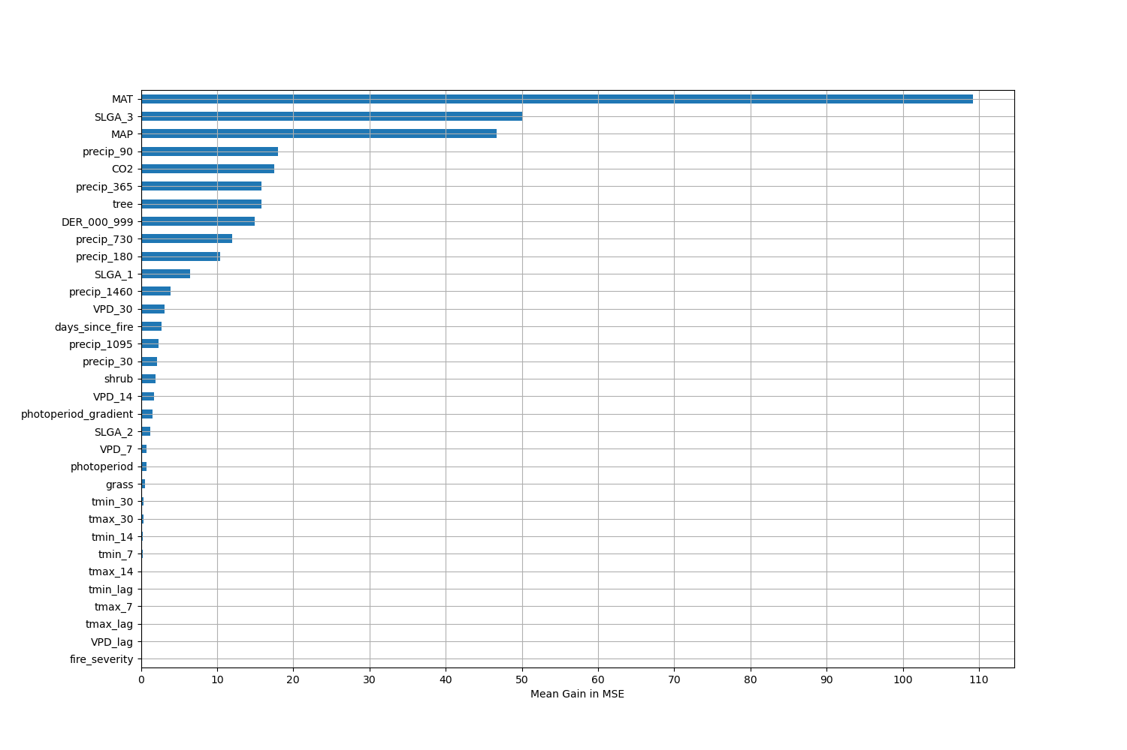

# Permutation Importance by Precip

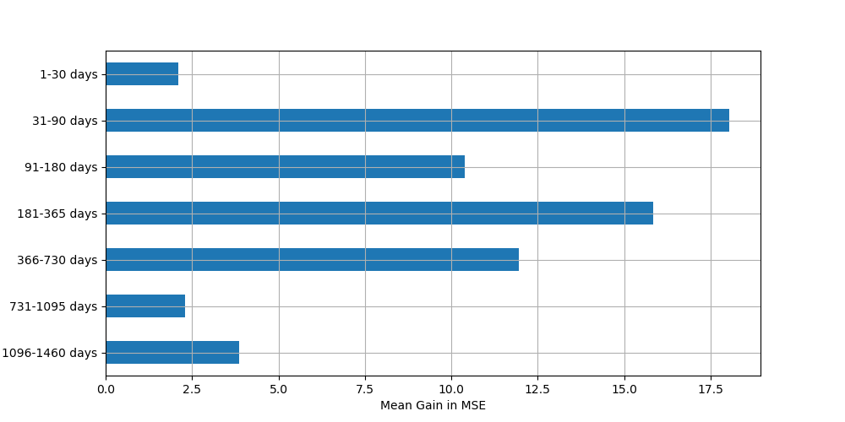

# ALE Importance

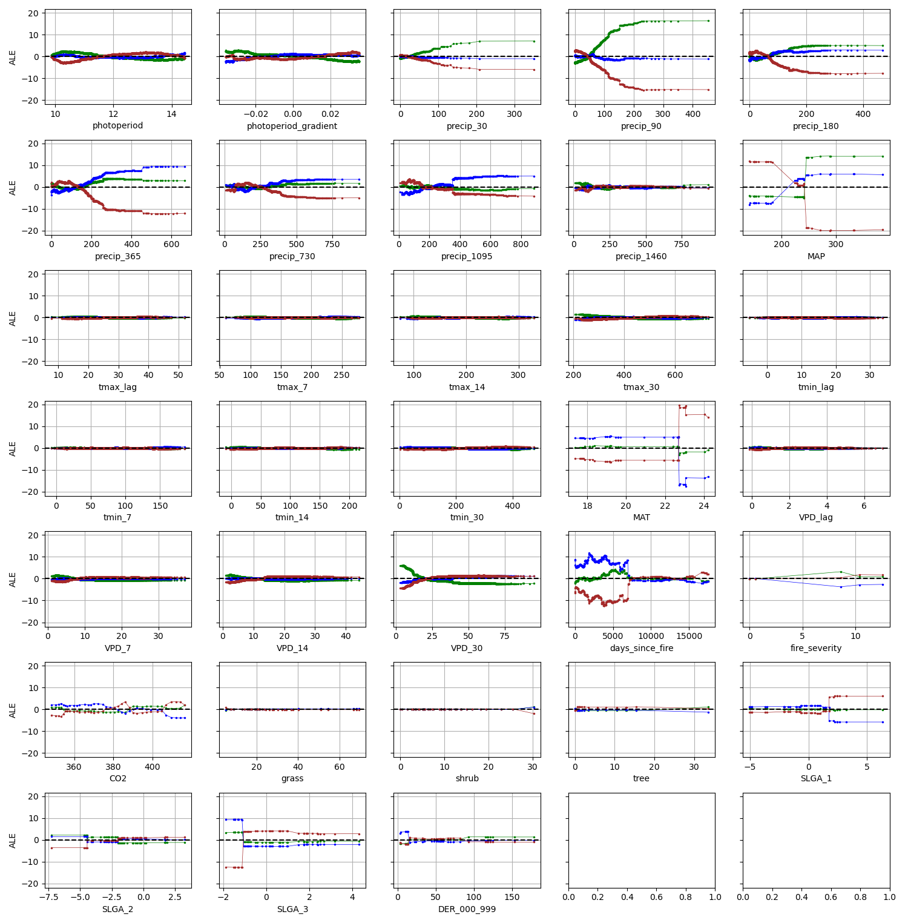

# NSABHC0009

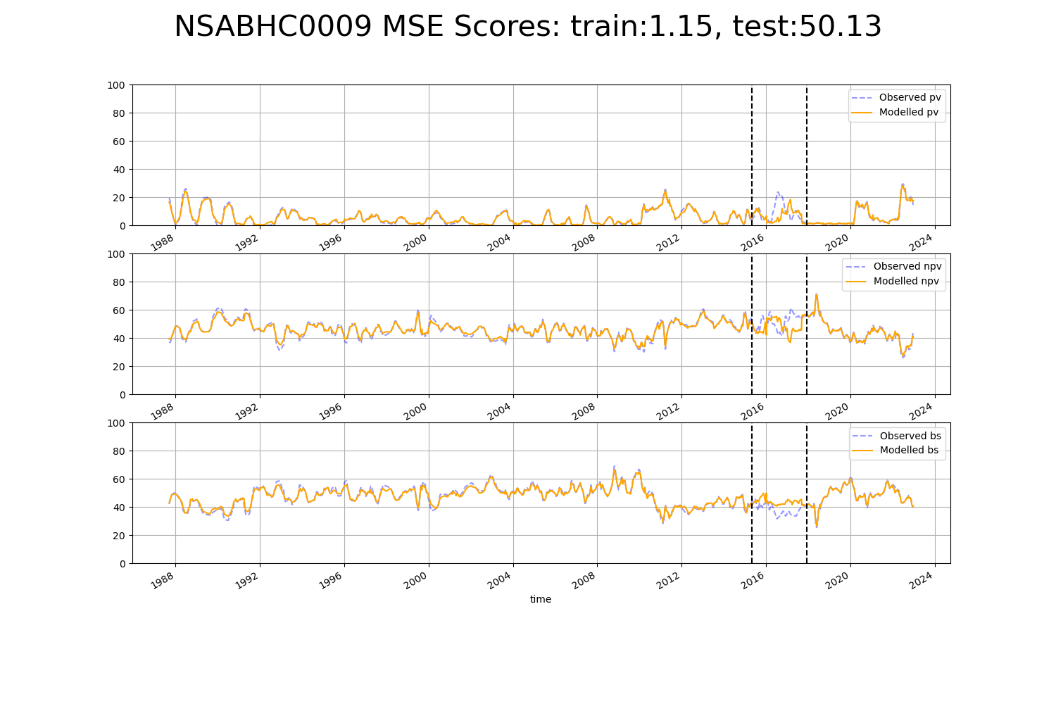

# NSABHC0012

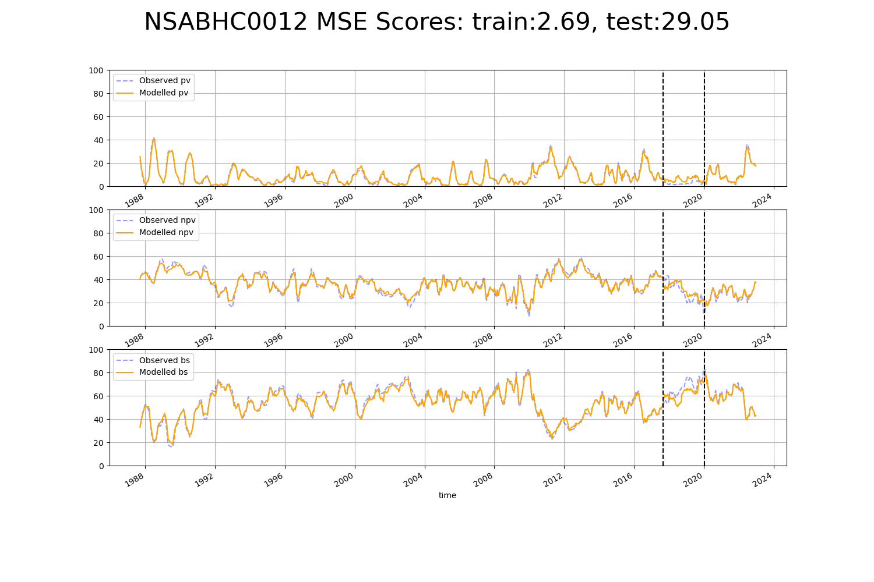

# NSABHC0023

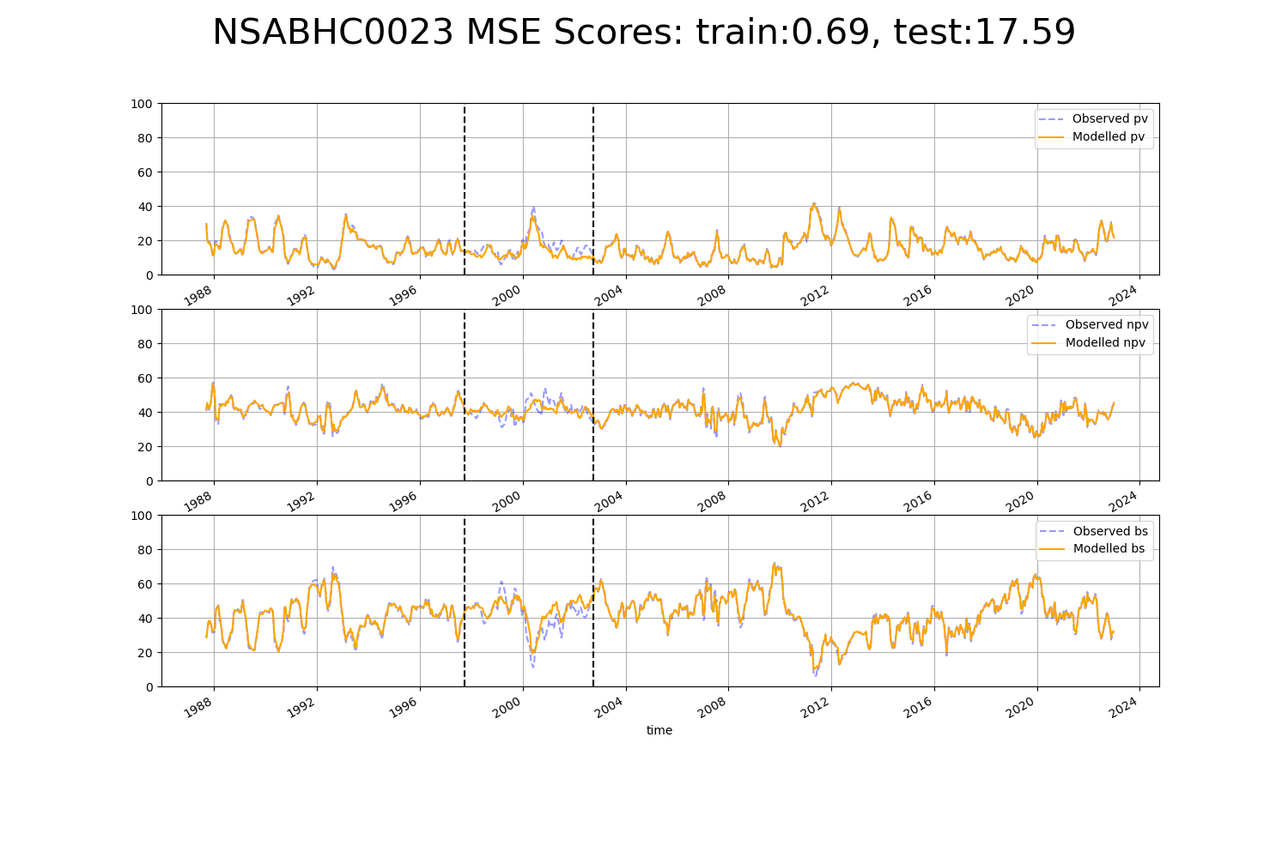

# NSABHC0024

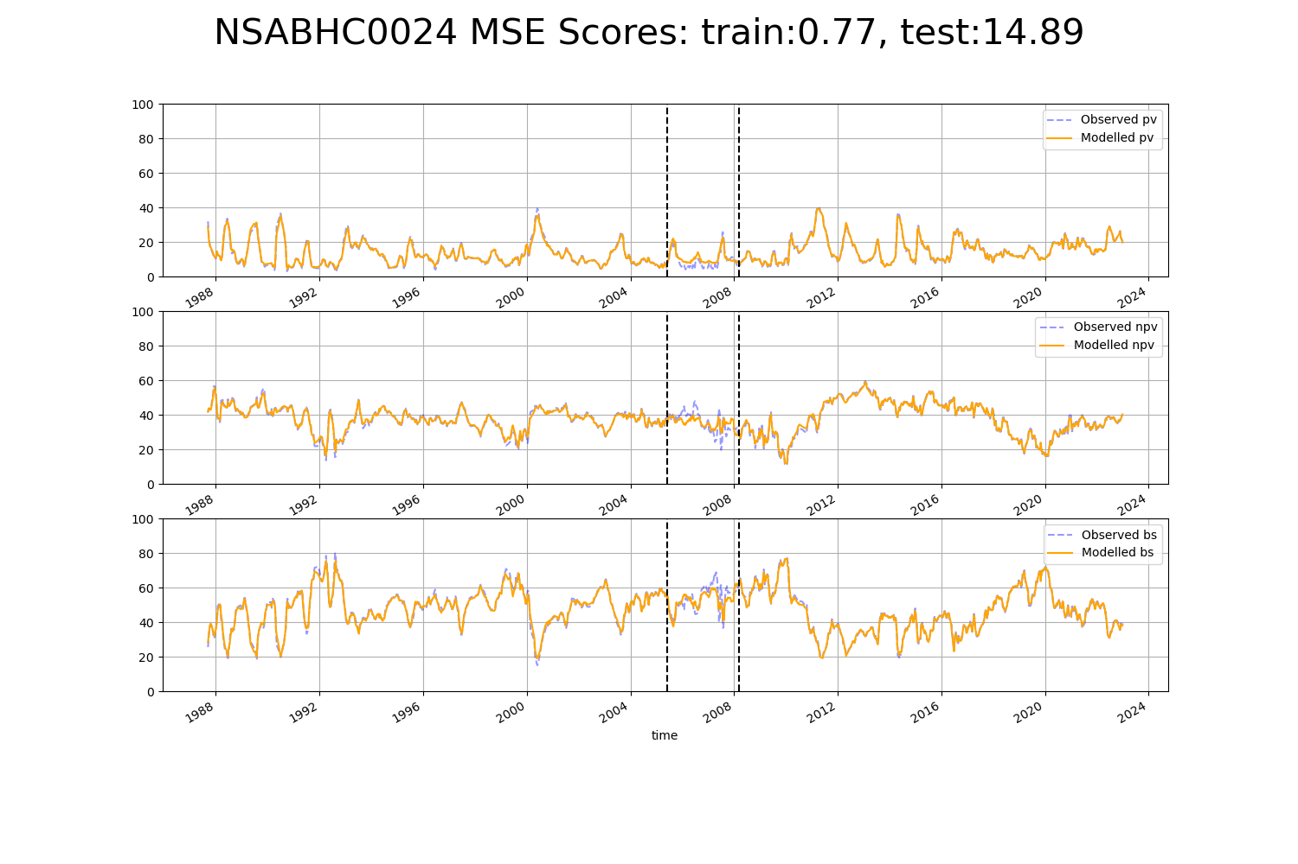

# NSABHC0026

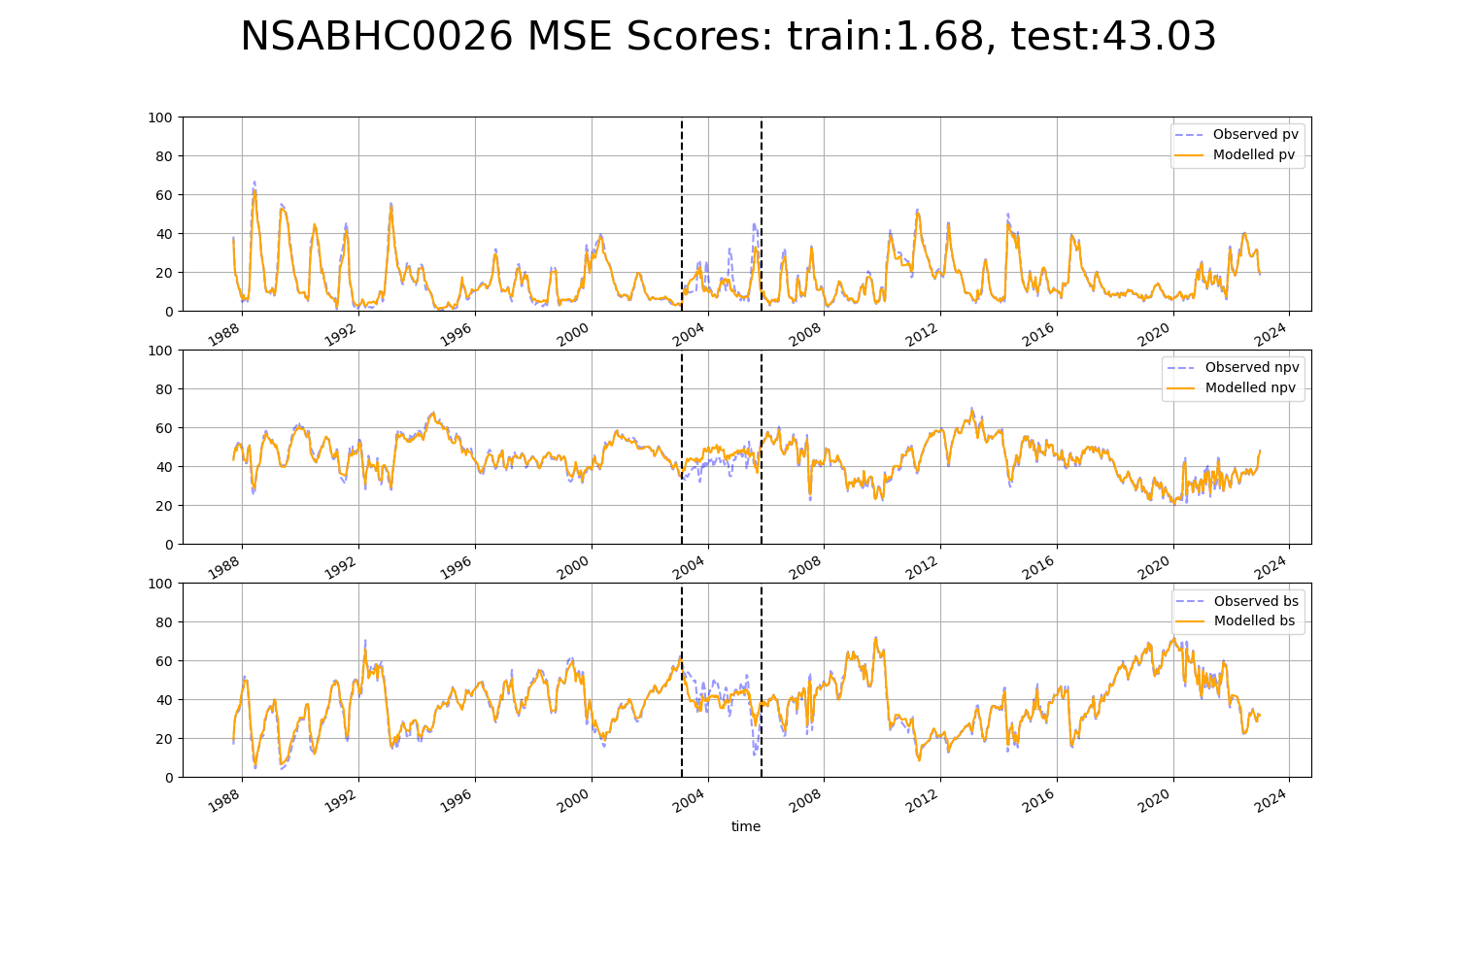

# NSAMDD0001

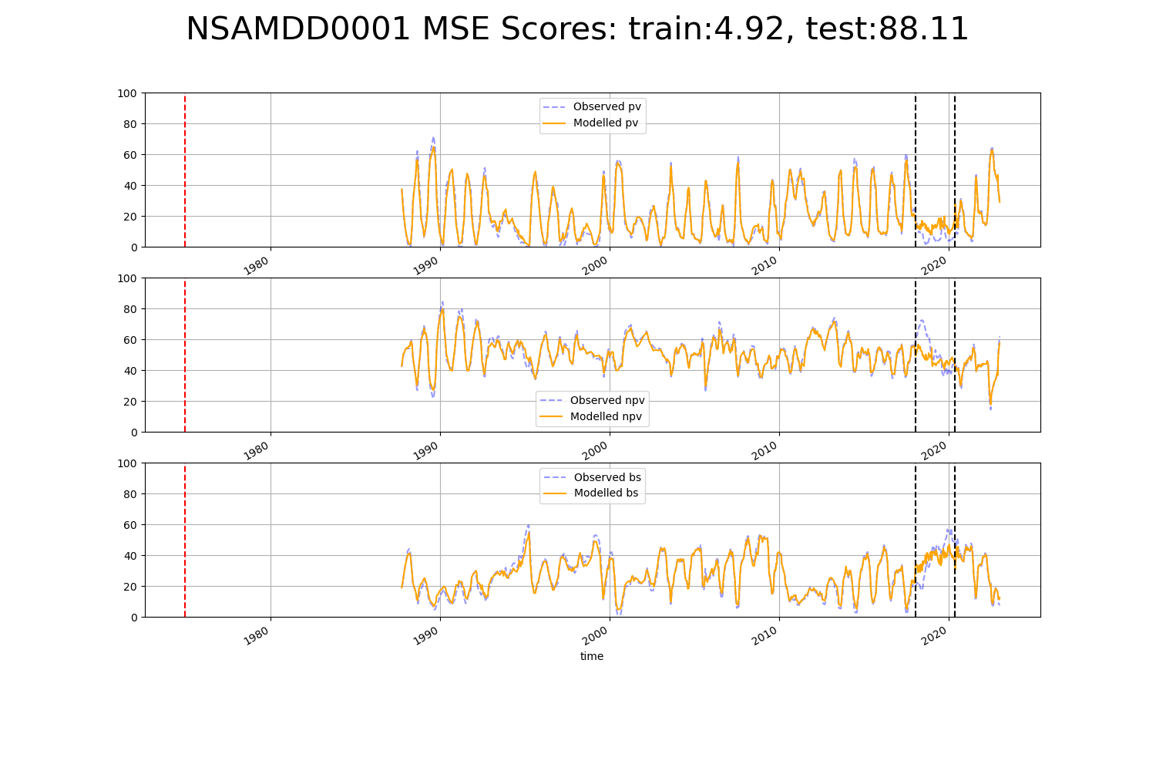

# NSAMDD0010

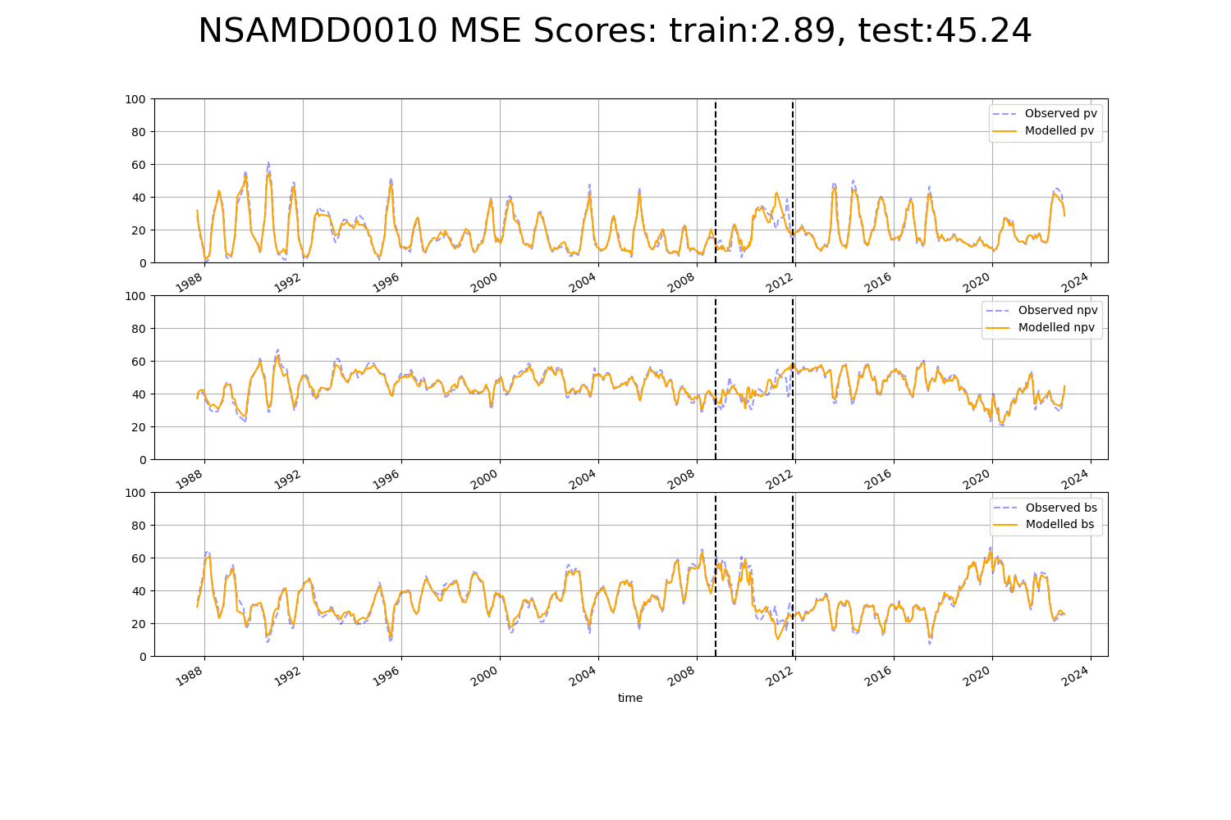

# NSAMDD0016

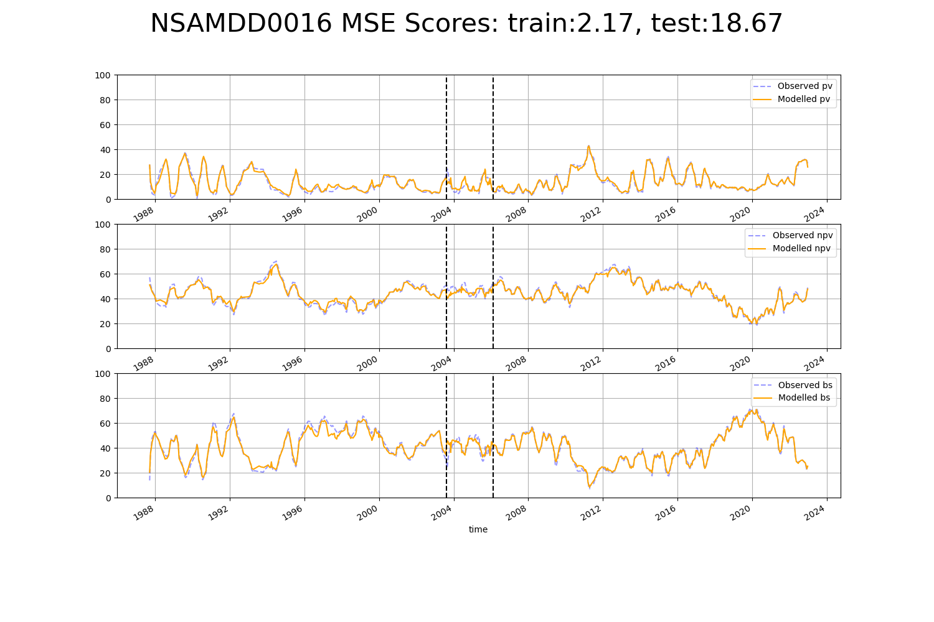

# NSAMDD0019

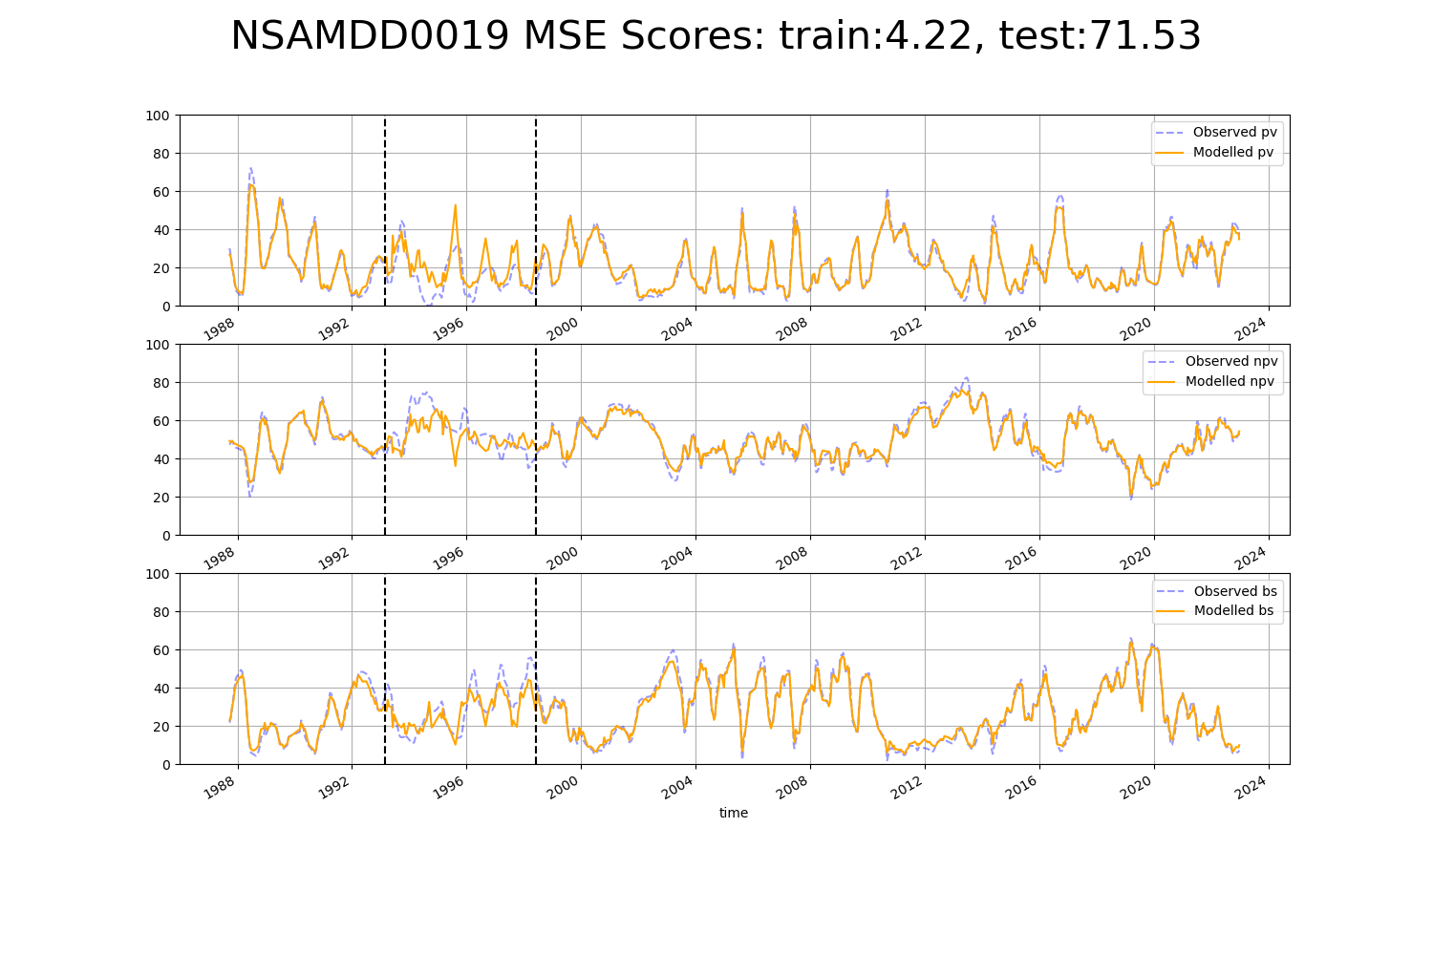

# NSAMDD0021

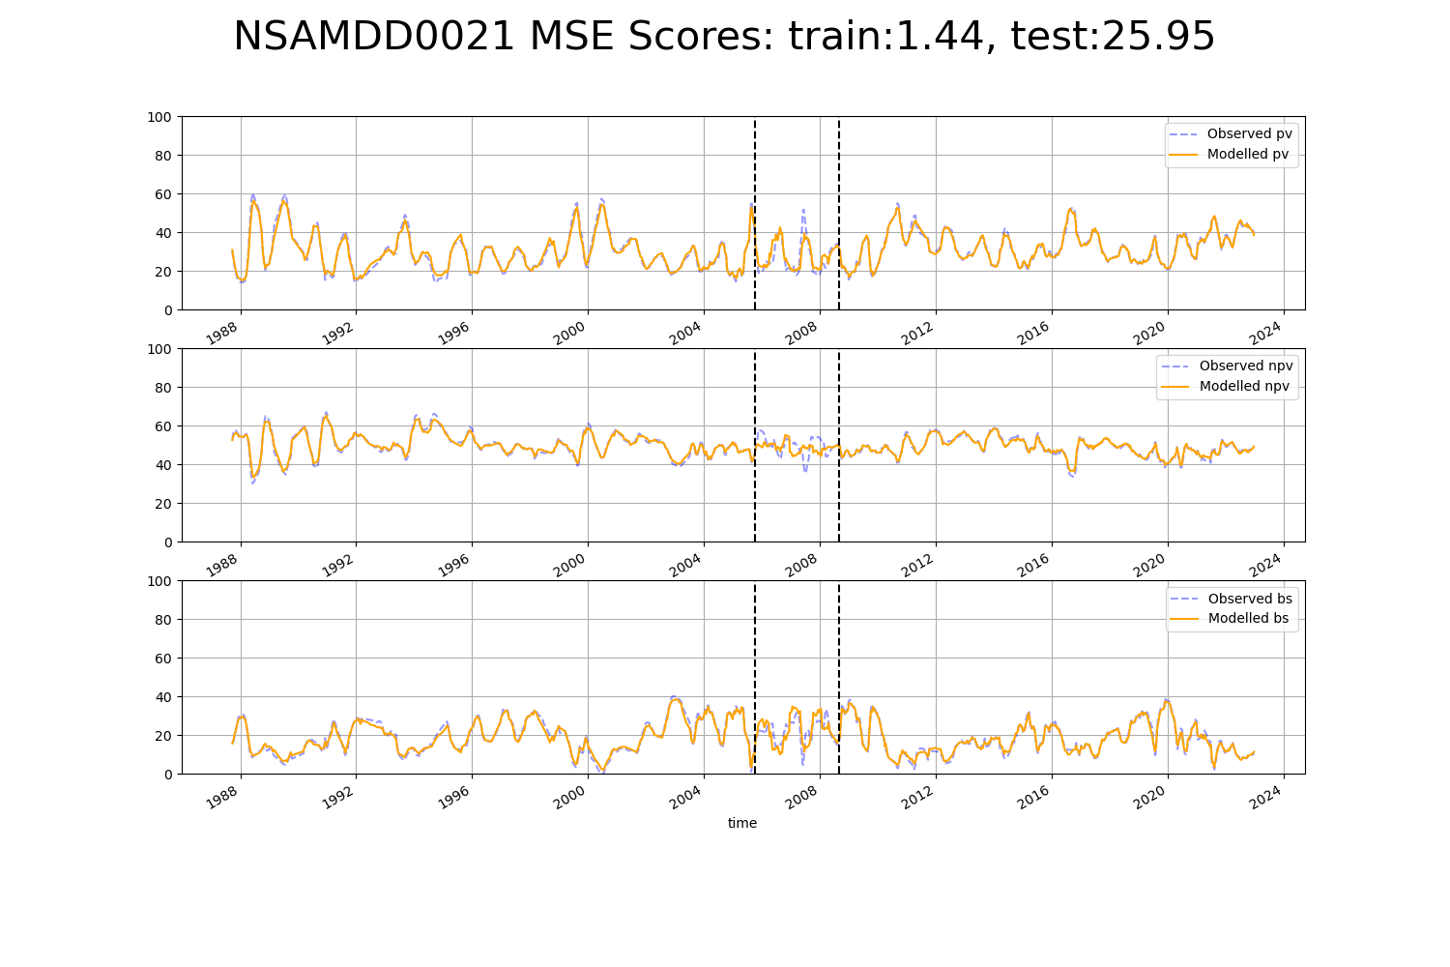

# NSAMDD0023

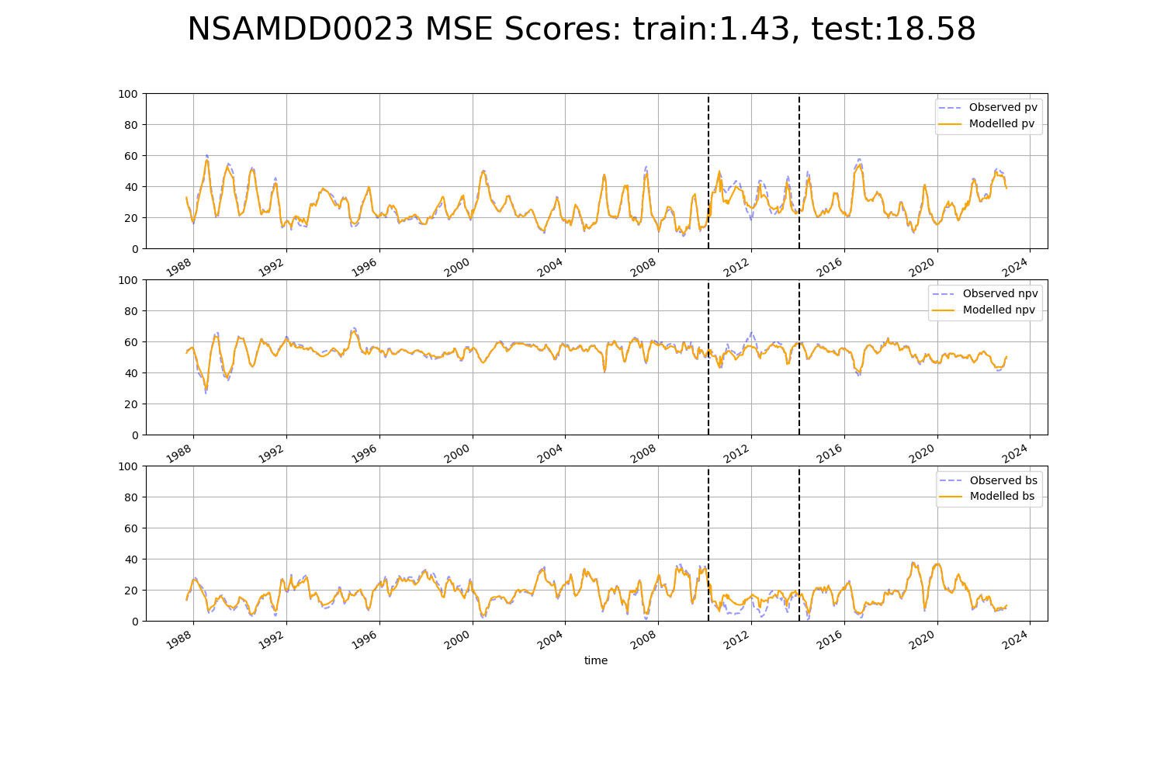

# NSAMDD0026

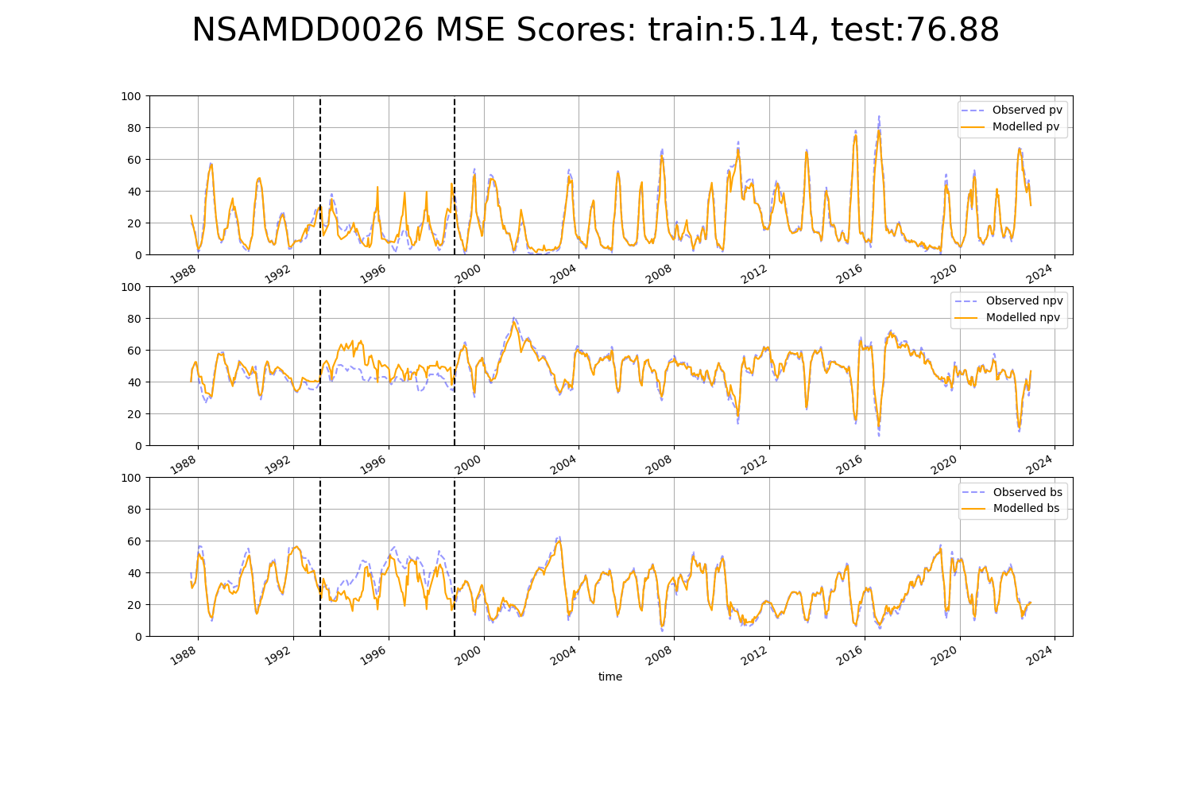

# NTASSD0003

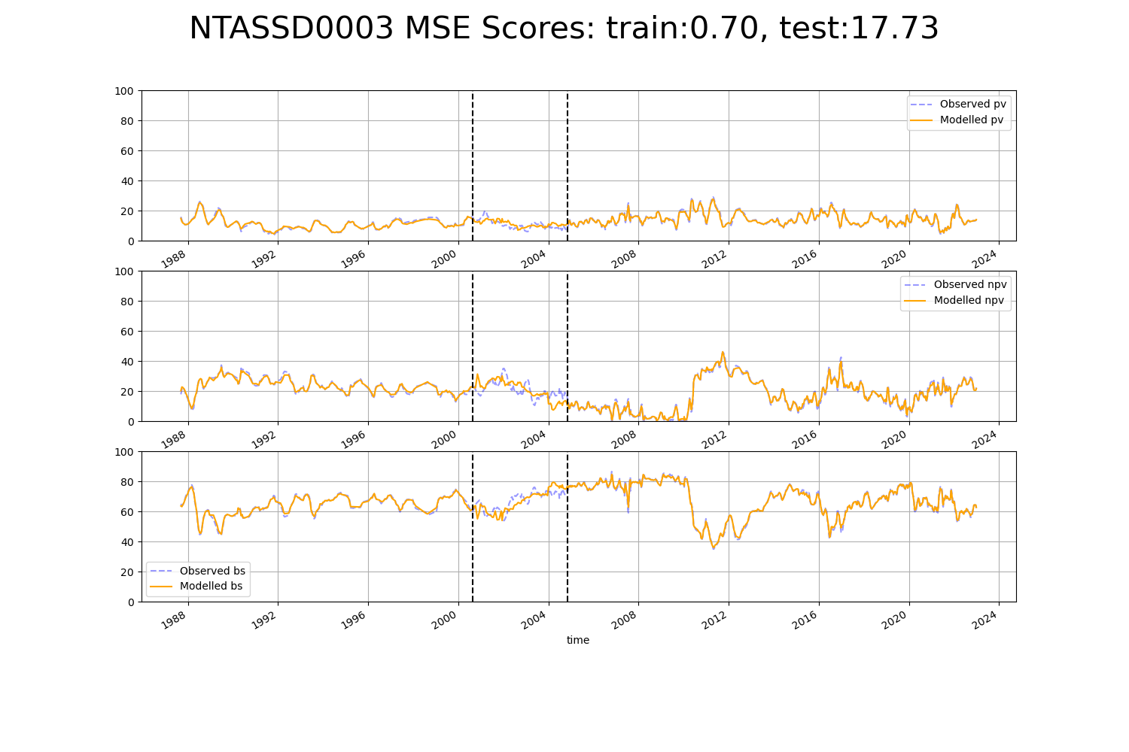

# NTASSD0005

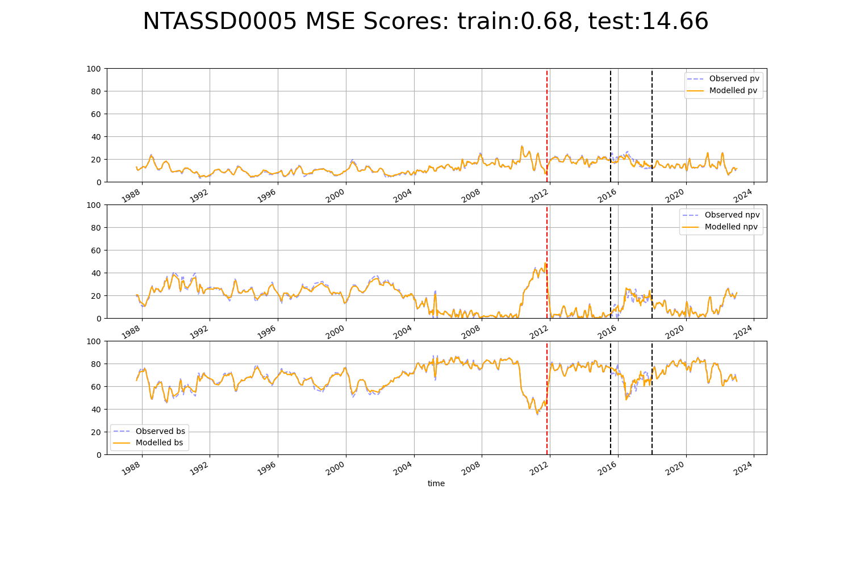

# NTASSD0007

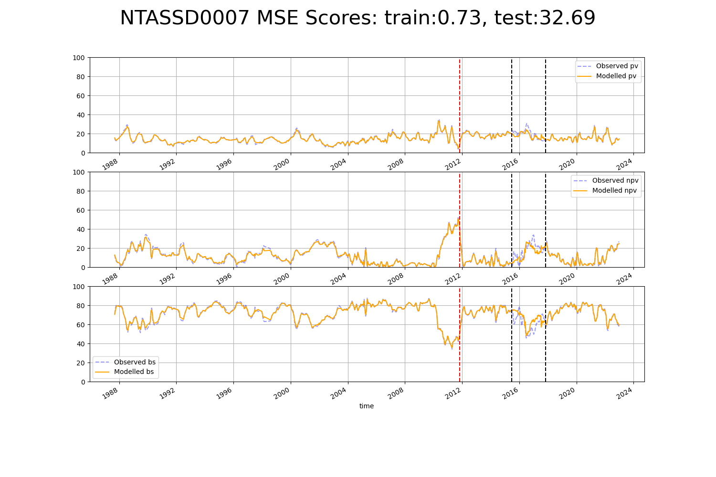

# NTASSD0010

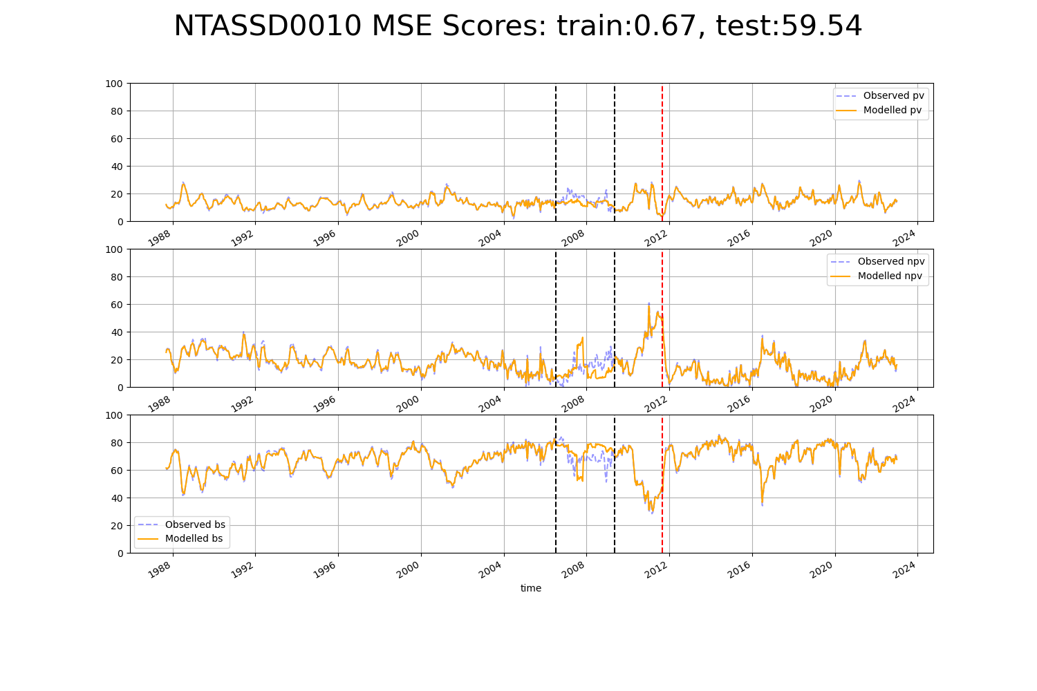

# NTASSD0014

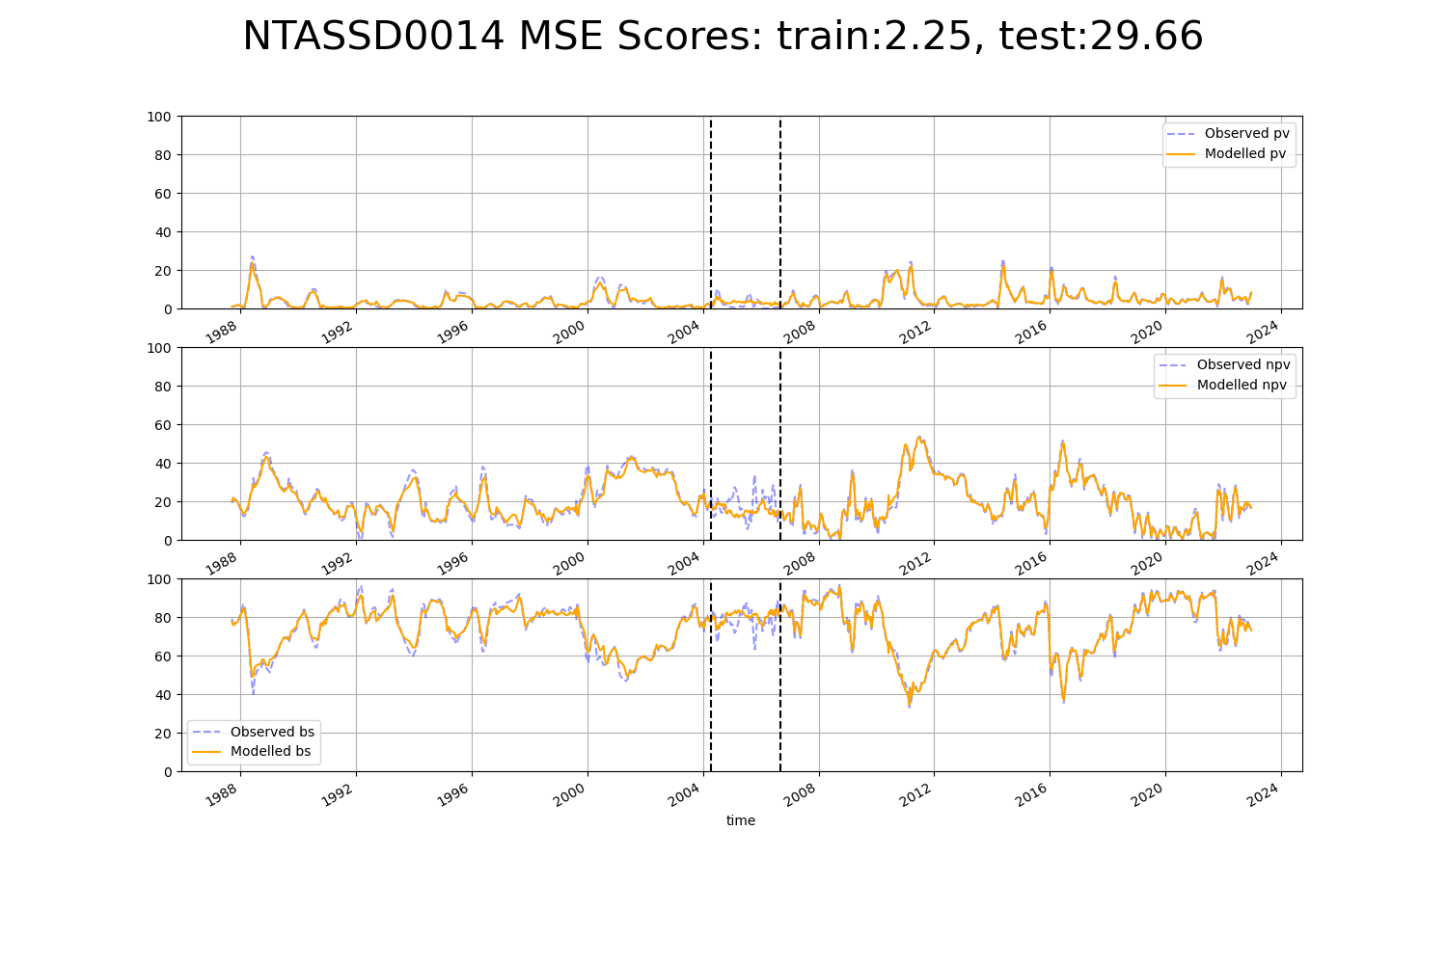

# NTASSD0015

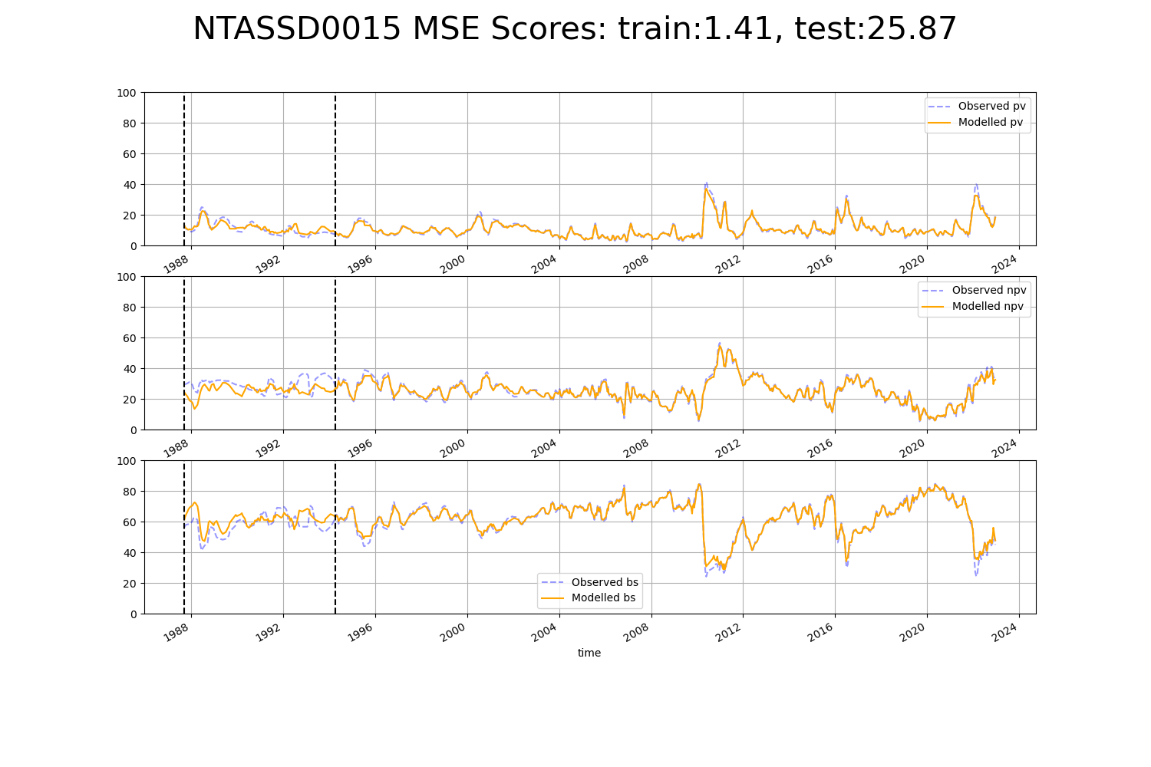

# QDAMGD0009

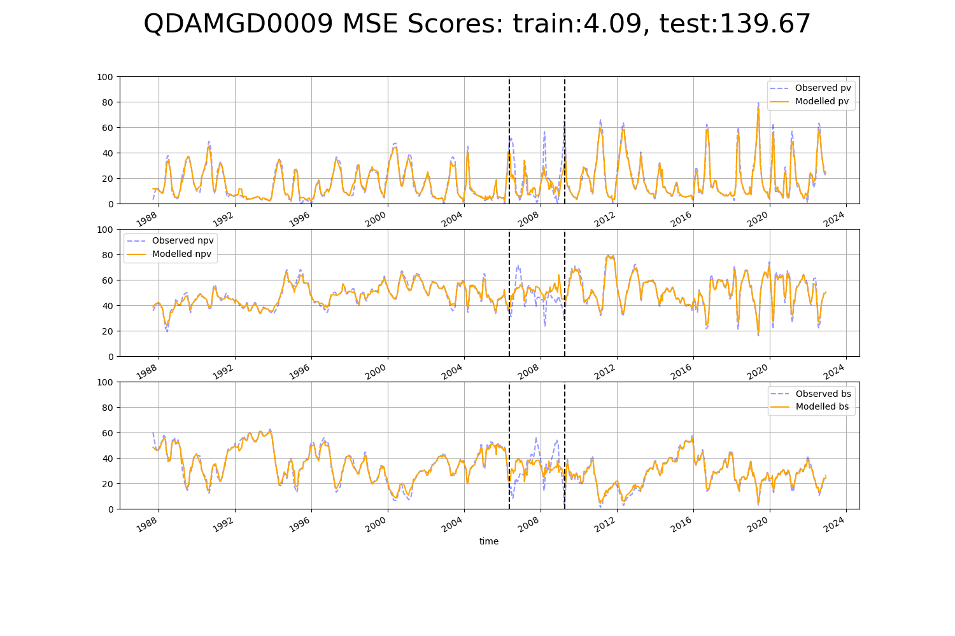

# QDASSD0012

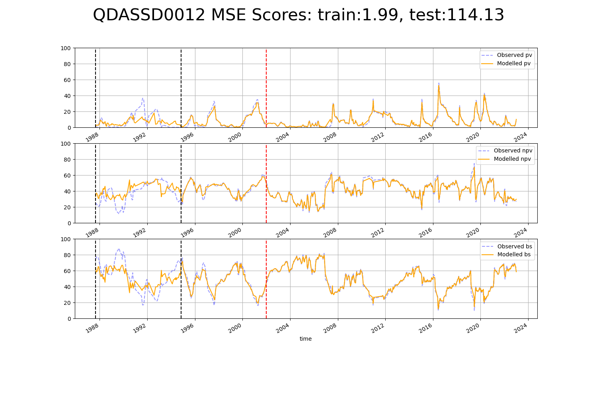

# SAAFLB0007

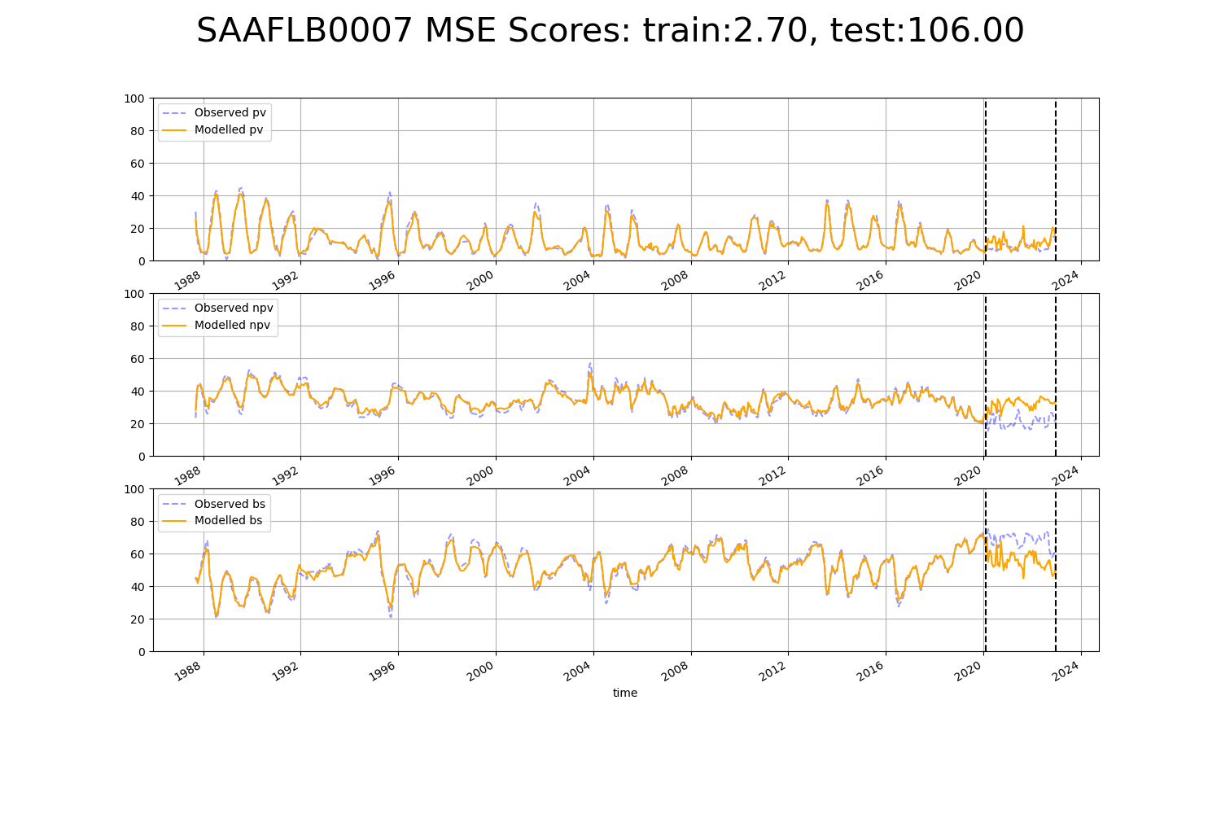

# SAARIV0004

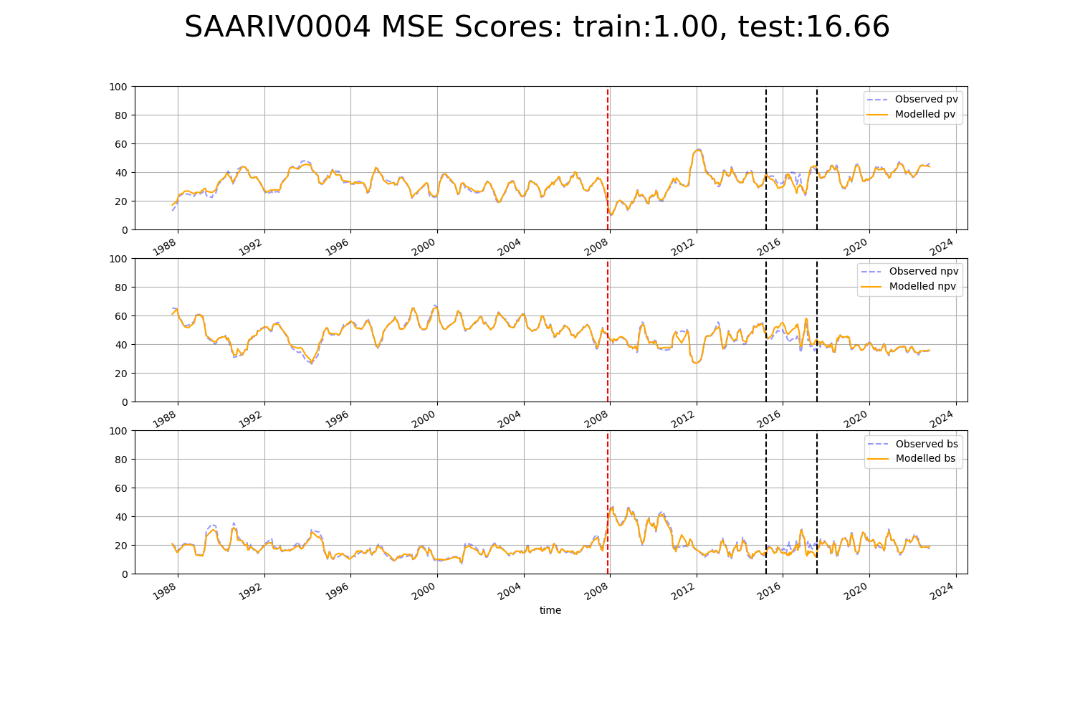

# SAARIV0005

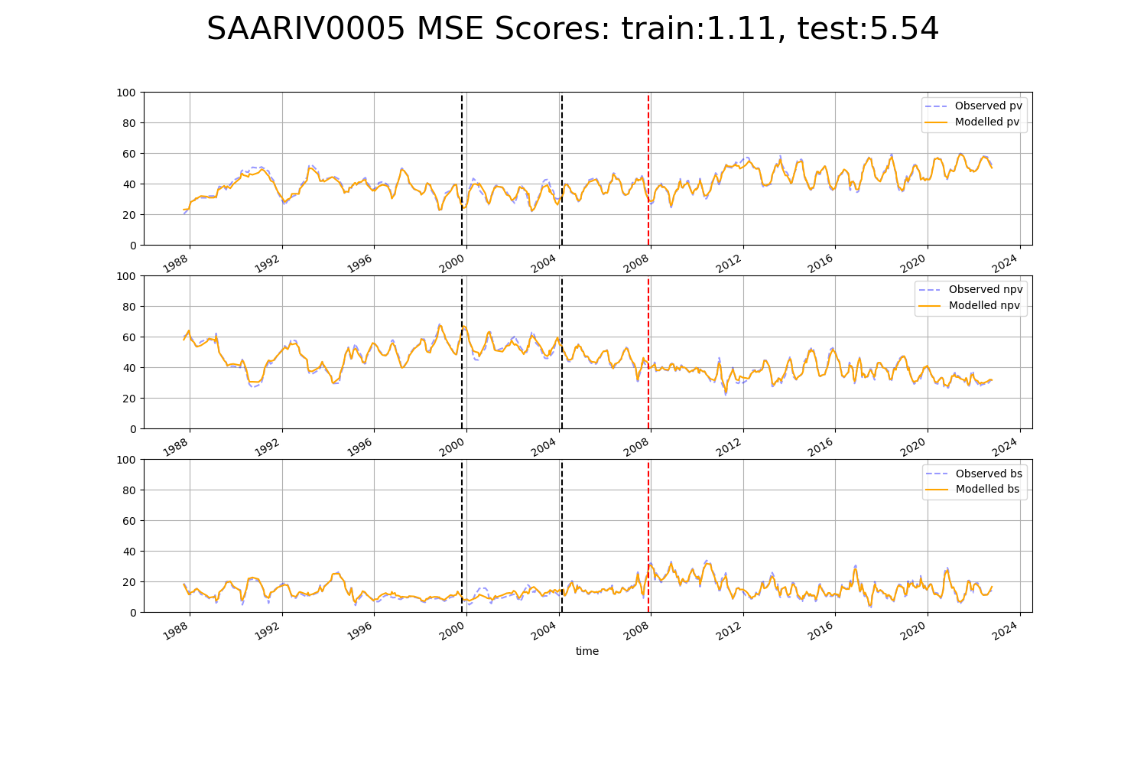

# SAARIV0006

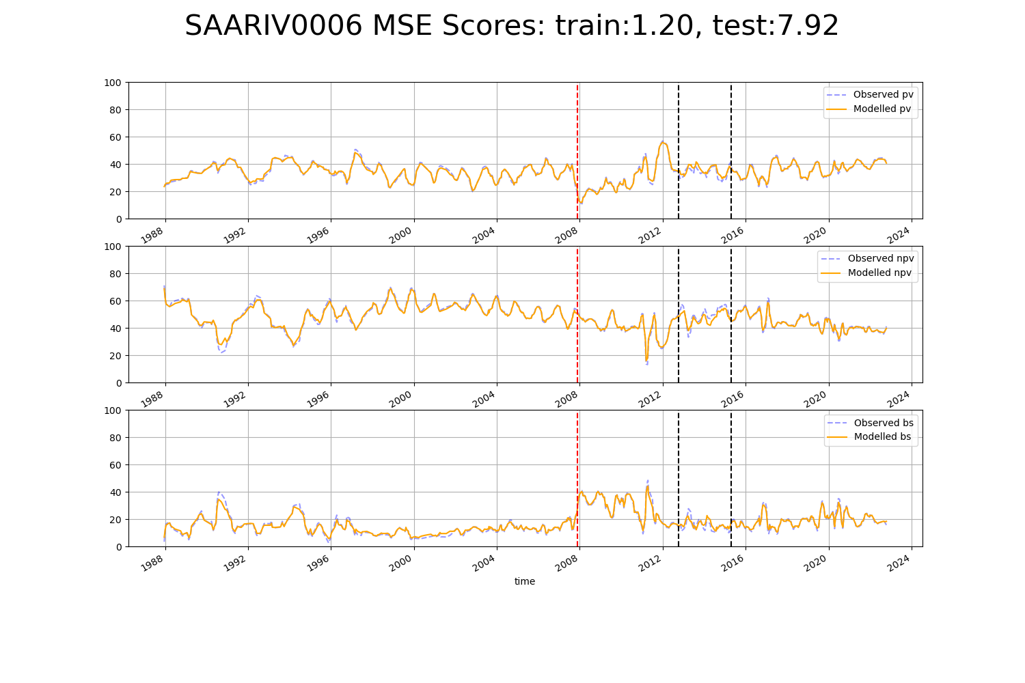

# SAASTP0004

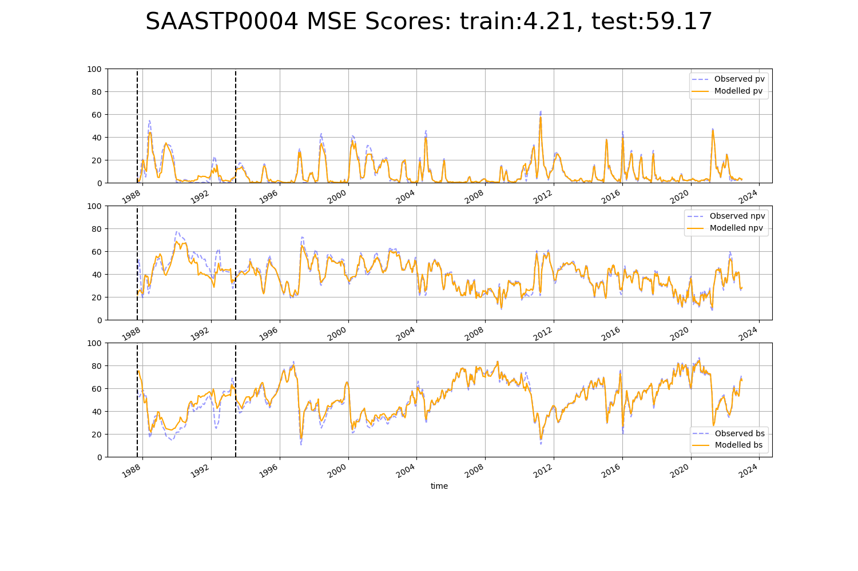

# SAASTP0005

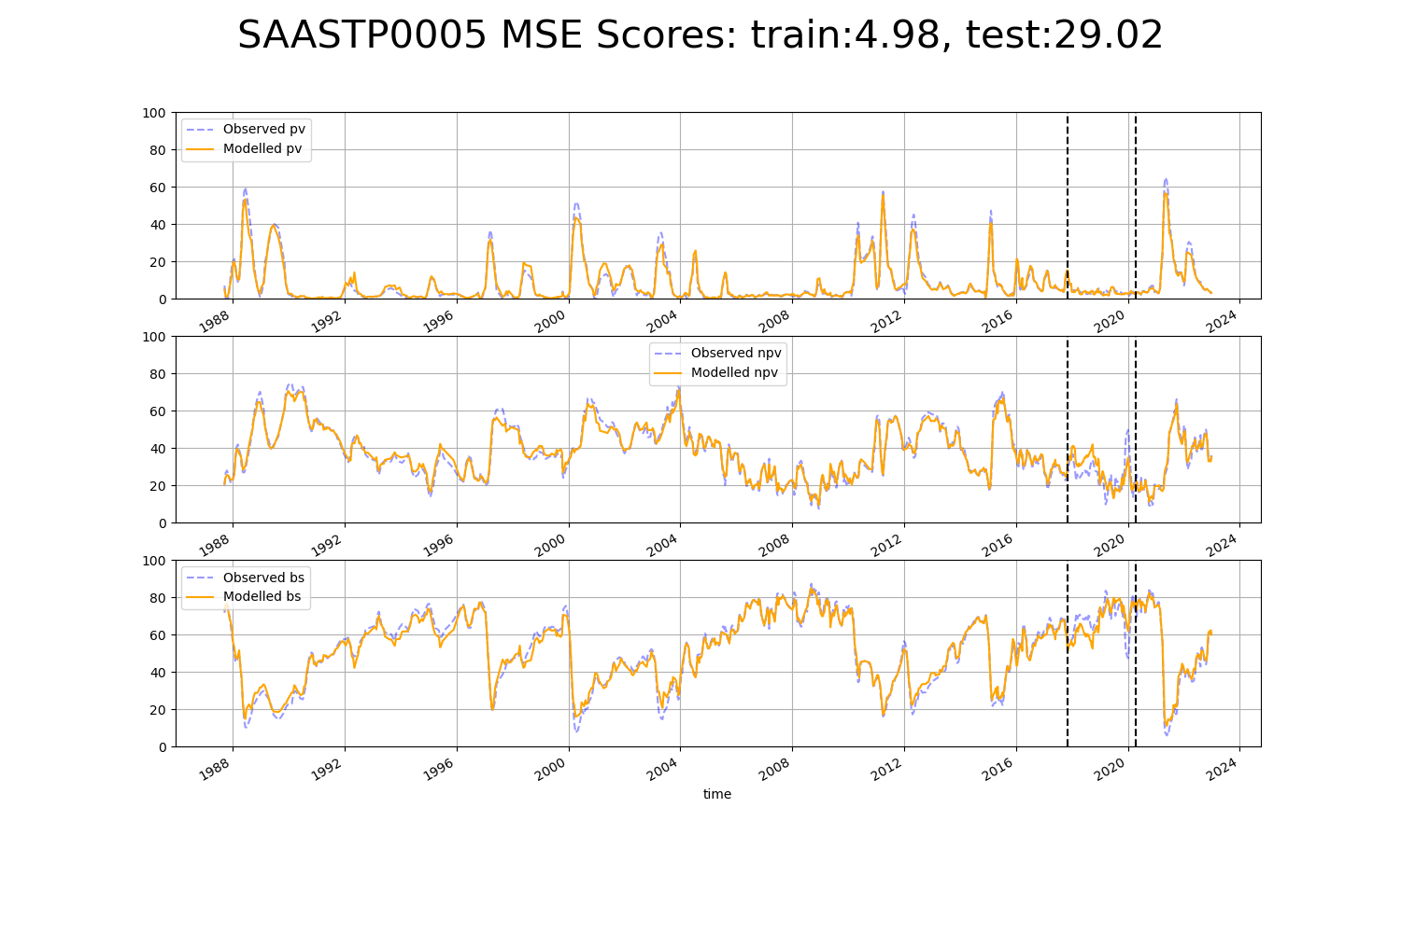

# SAASTP0006

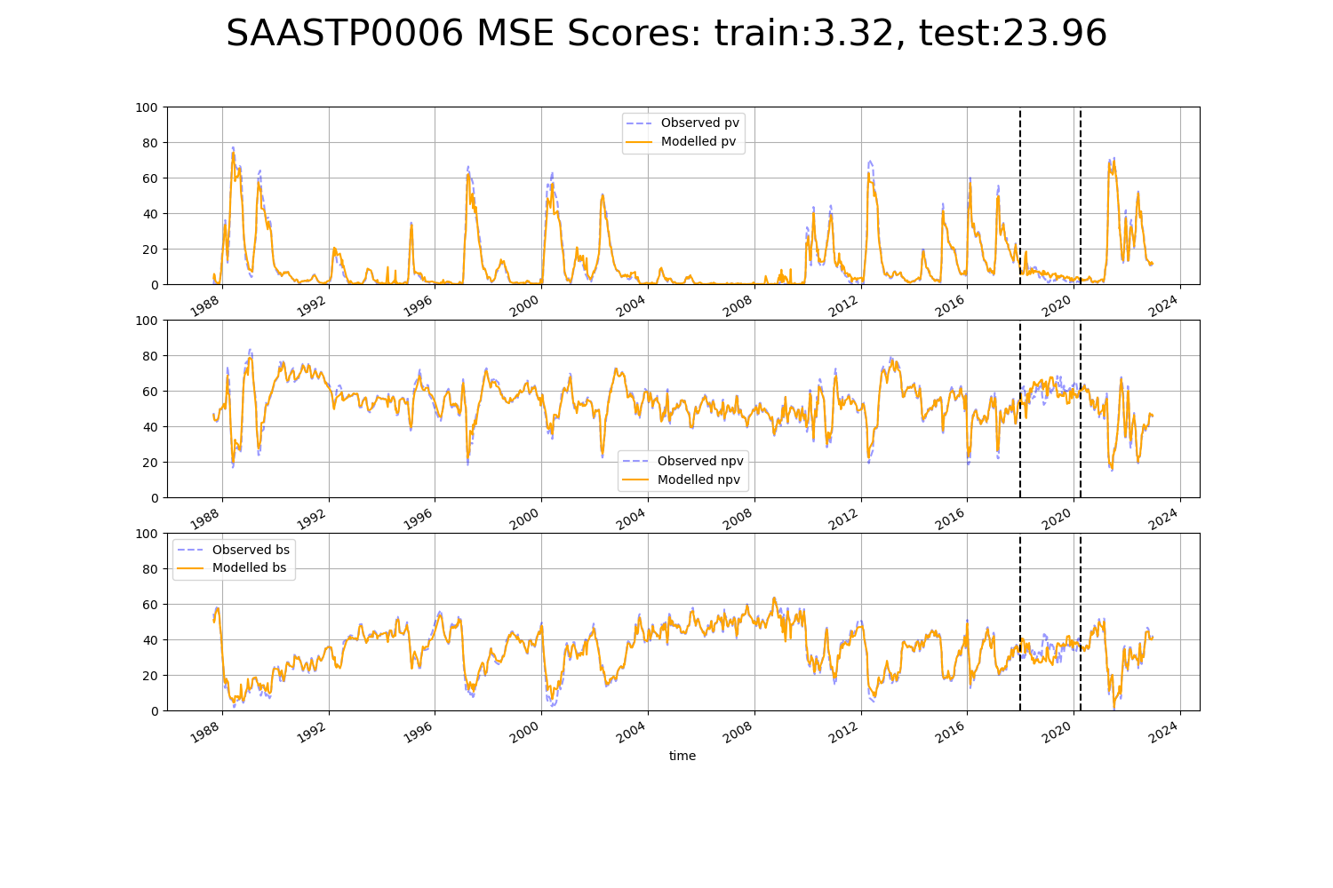

# SASMDD0005

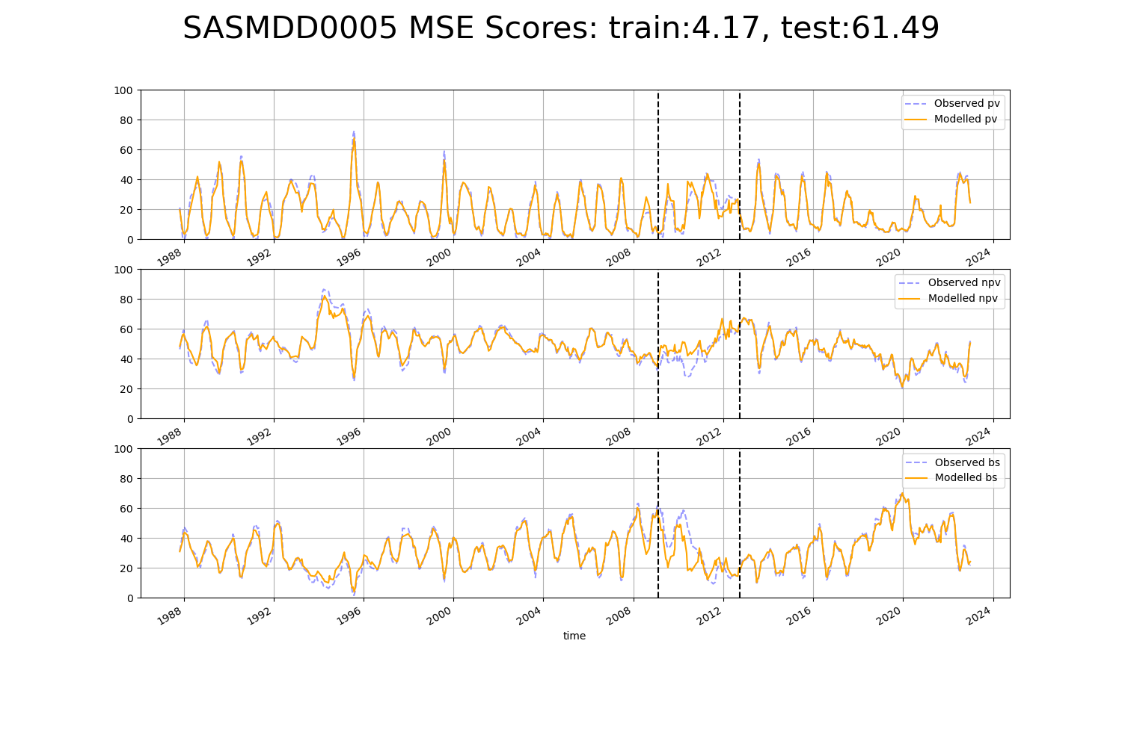

# SATSTP0007

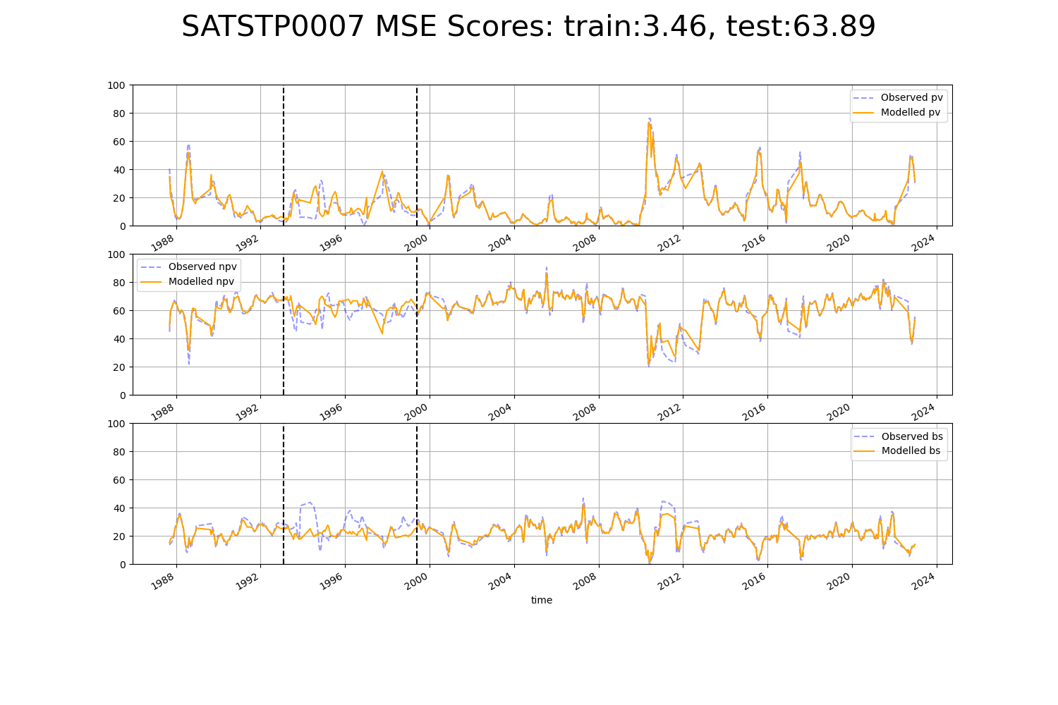

# WAAHAM0004

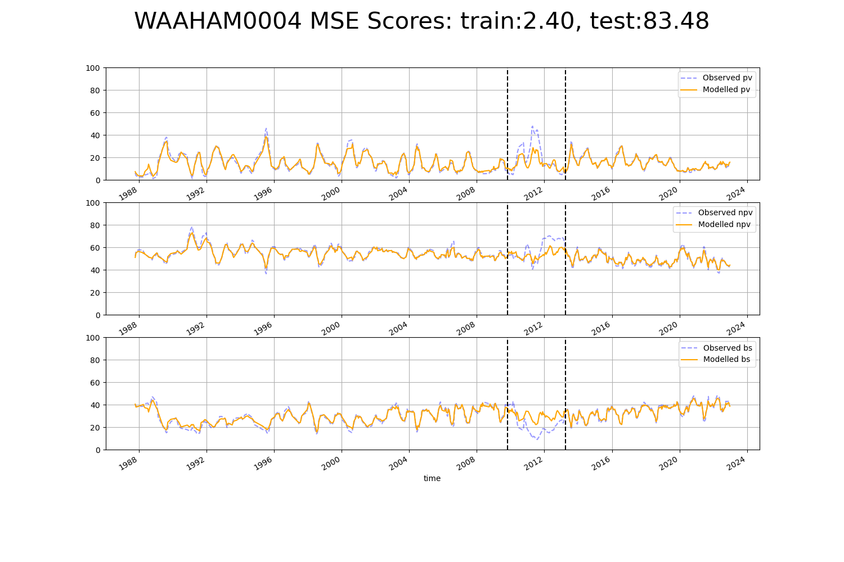

# WAAMUR0003

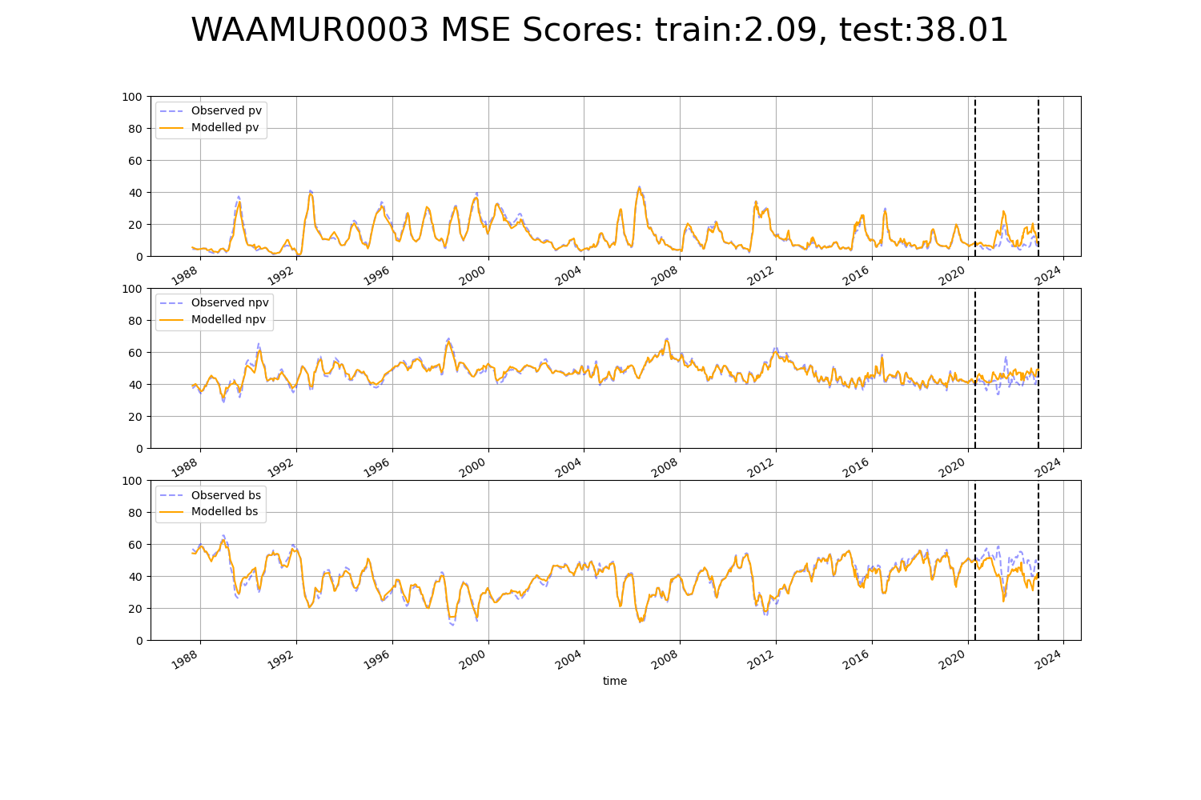

# WAAMUR0004

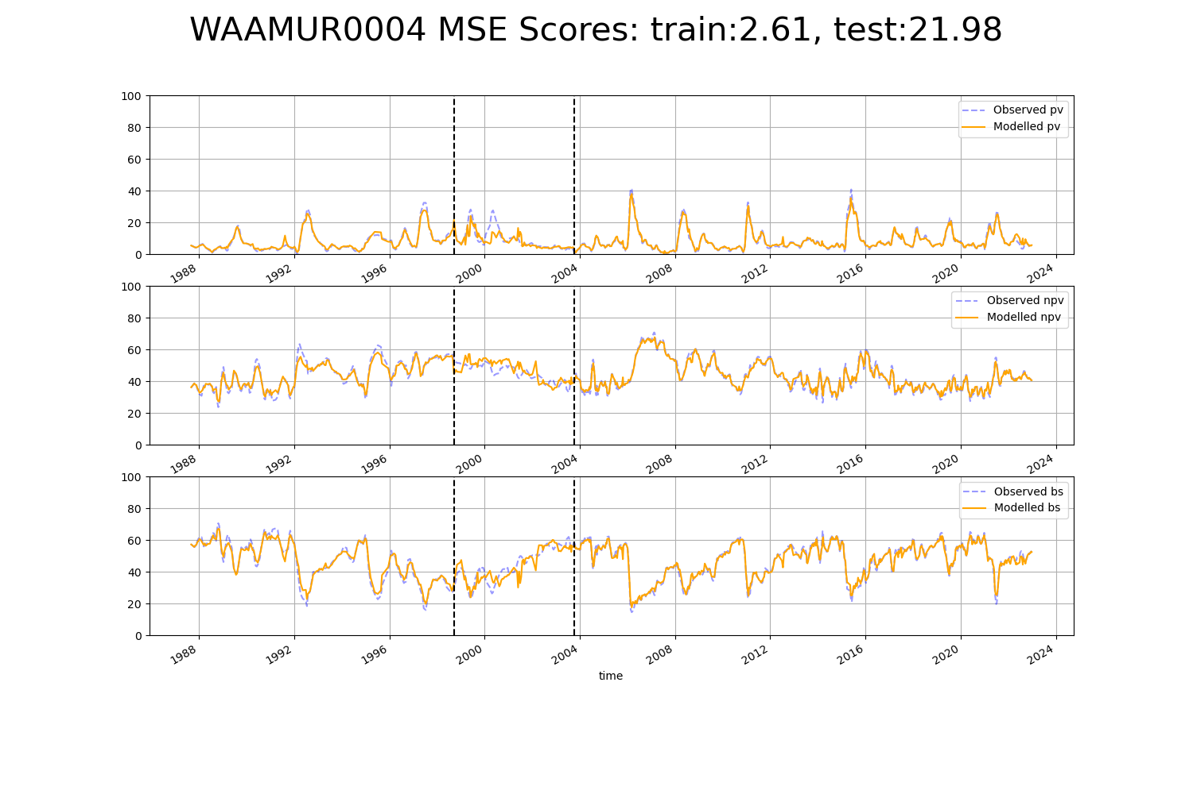

# WAAMUR0007

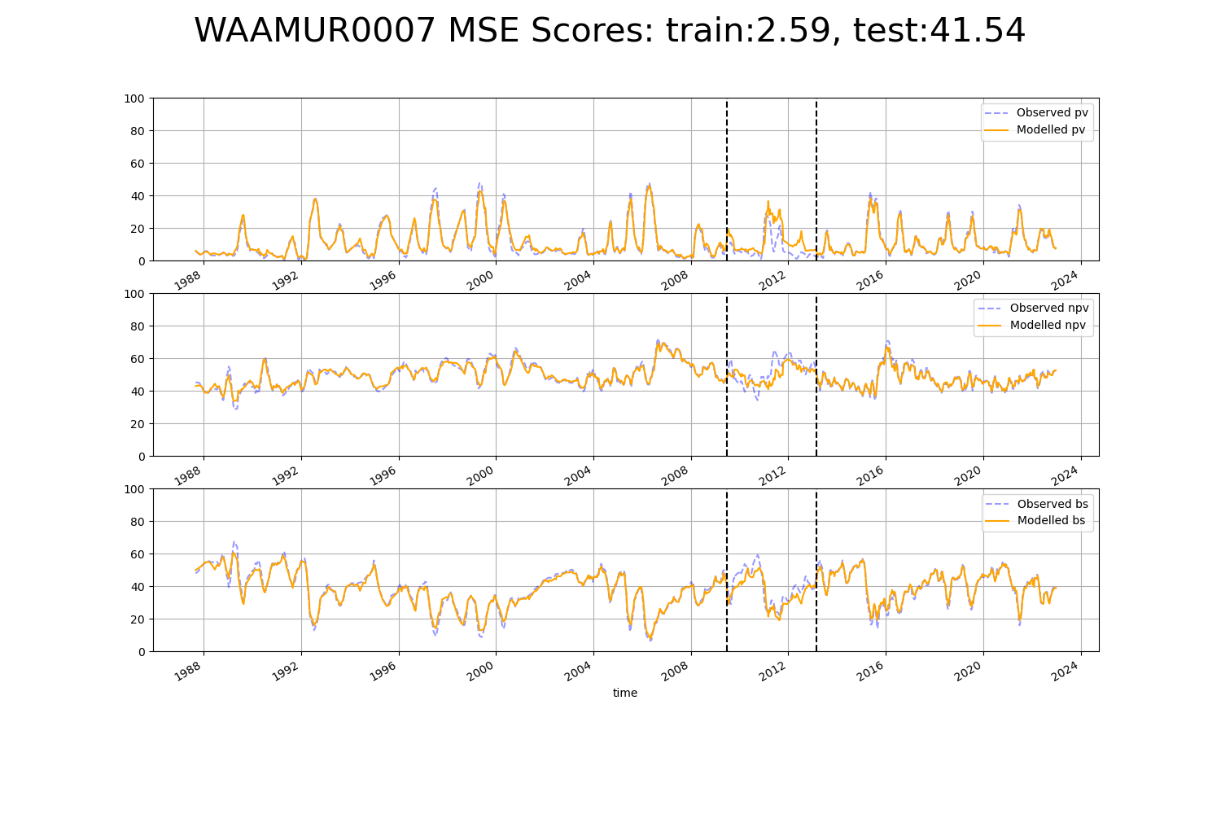

# WAAMUR0008

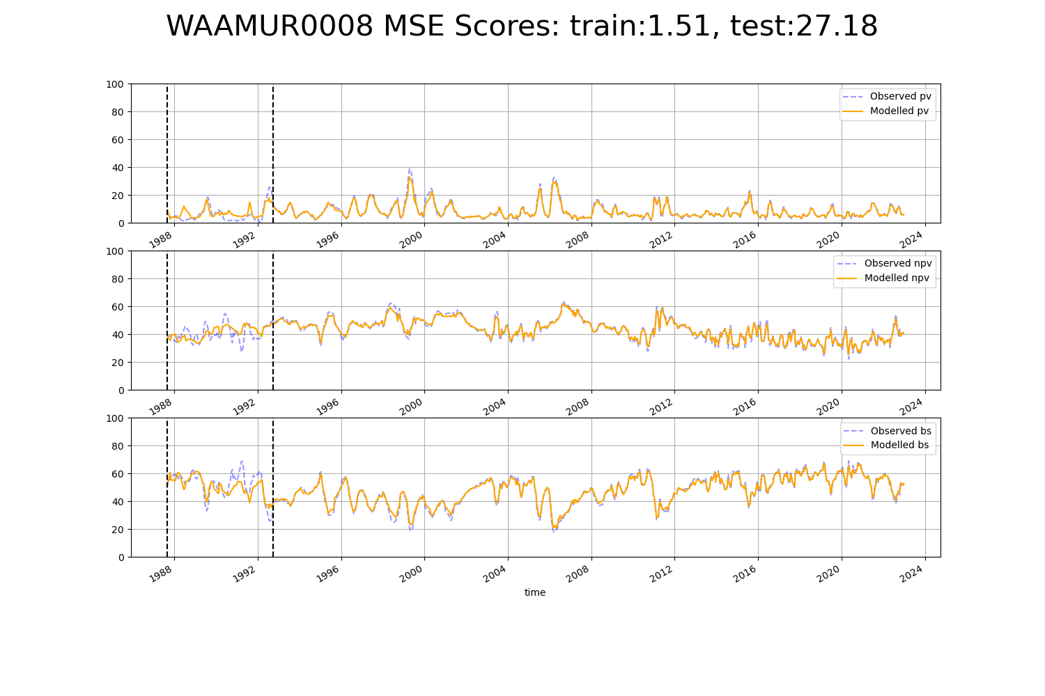

# WAANUL0002

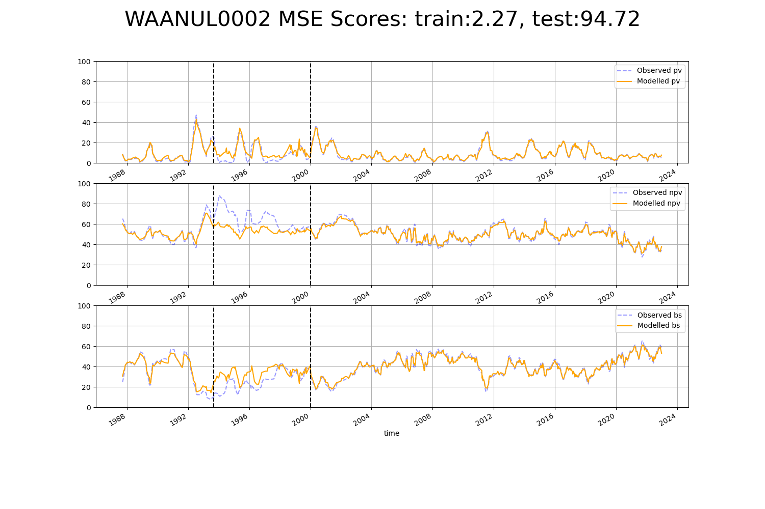

# WAANUL0005

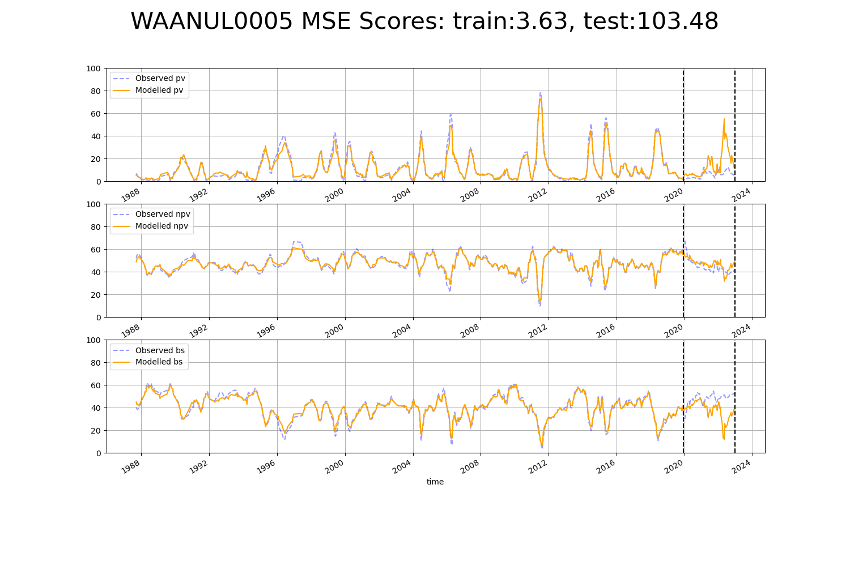

# WAANUL0006

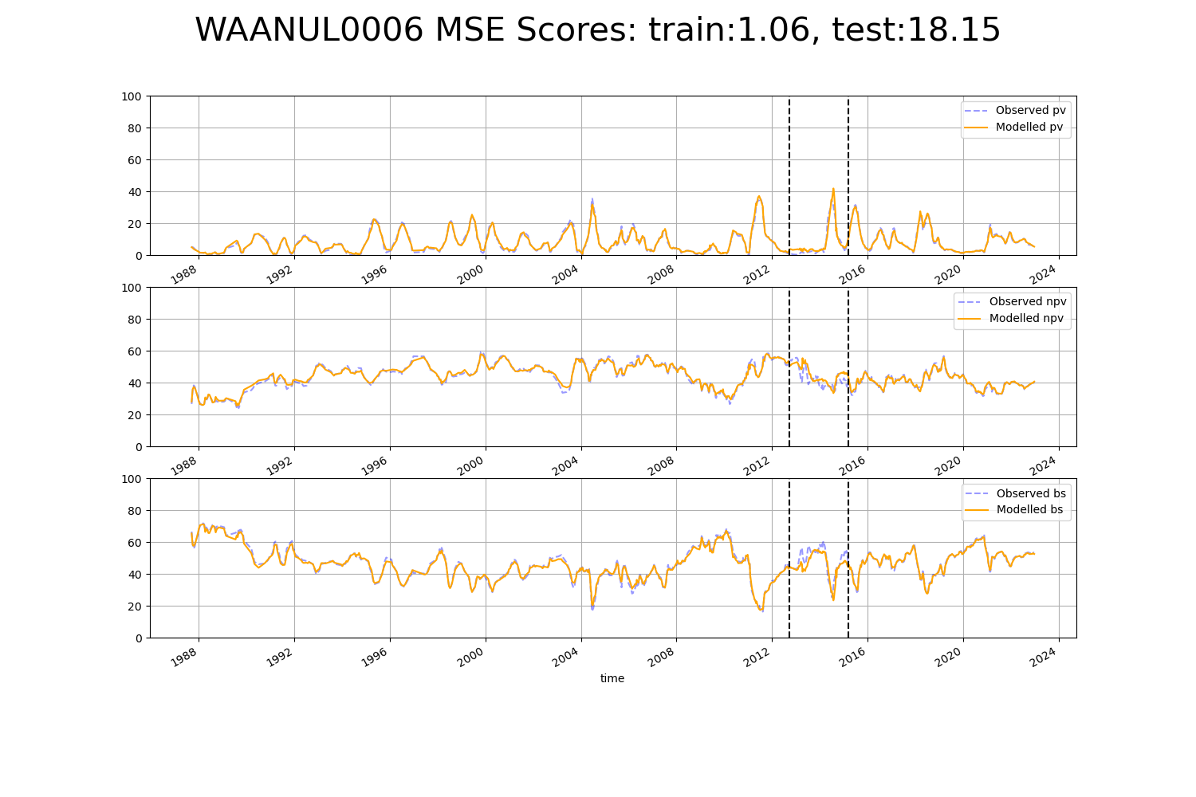

# WAANUL0007

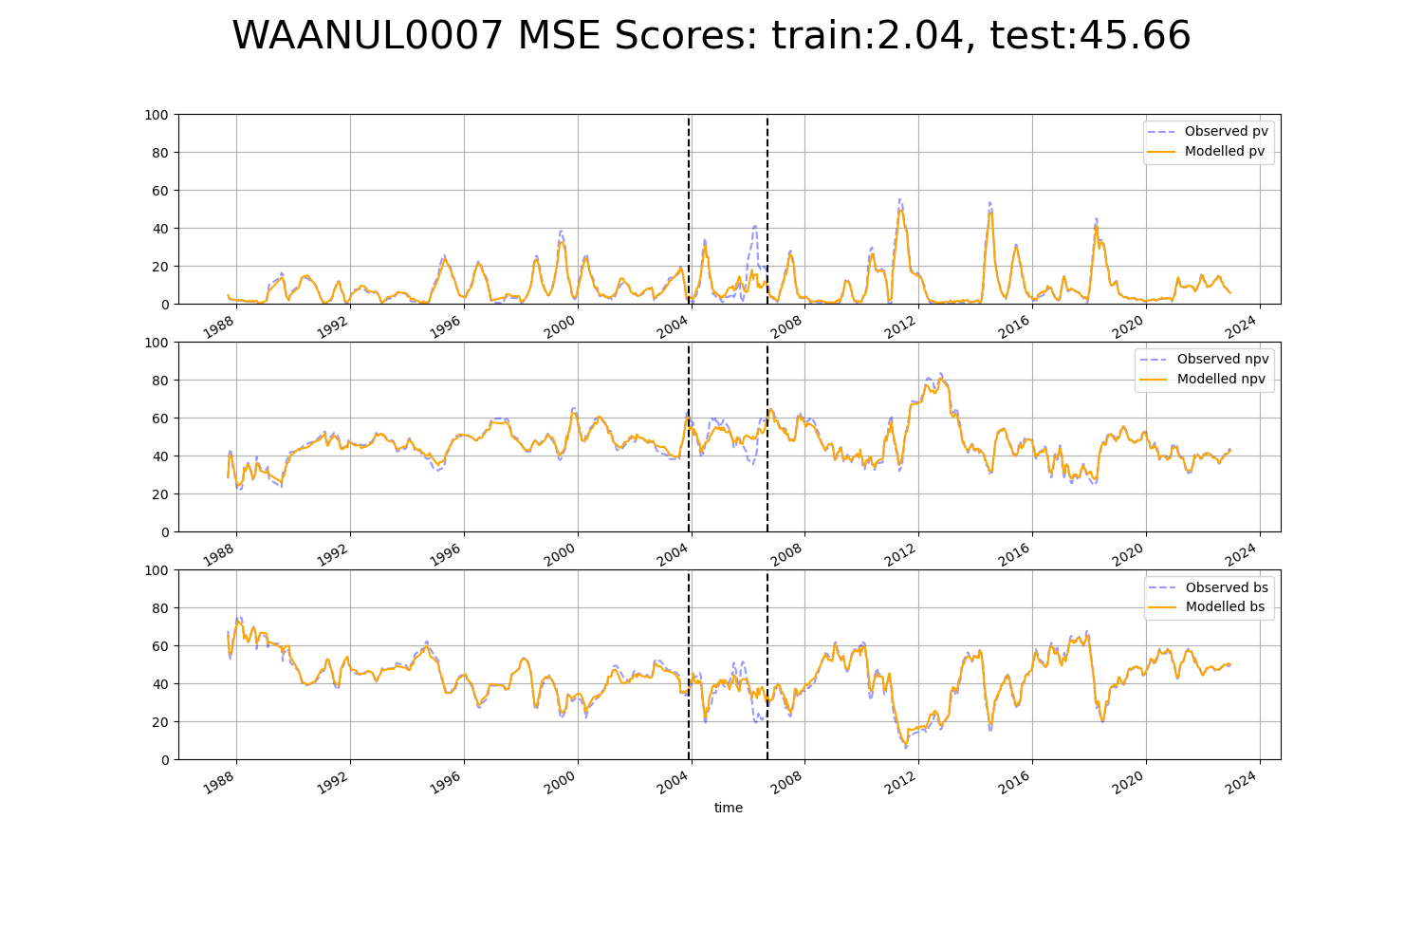

# WAAYAL0004

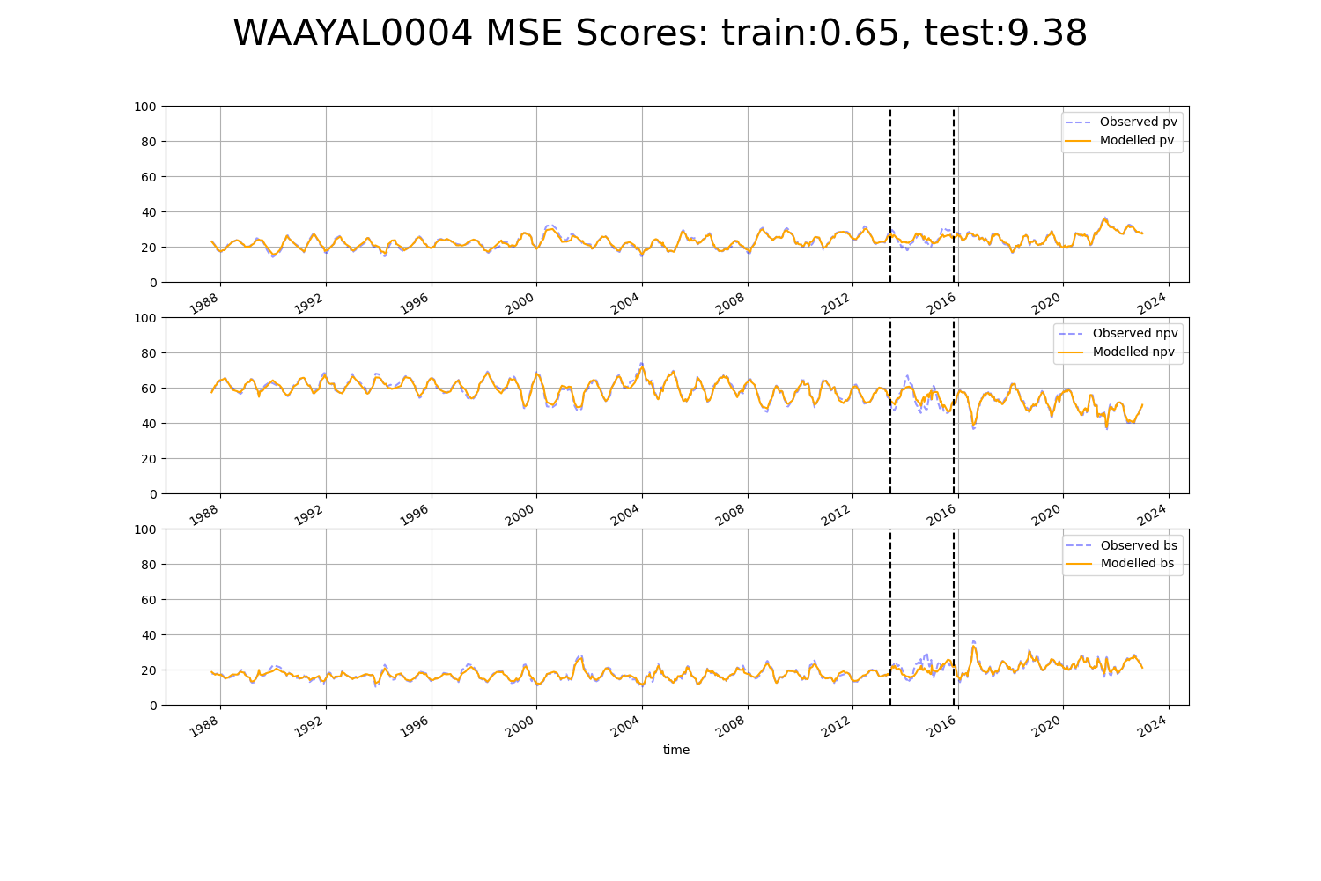

# SASMDD0013

